Press Release
To download press materials, please click here.

New Artistic Dialogues Unfold at Louvre Abu Dhabi with the Arrival of New Masterpieces
The new artworks include unique acquisitions and international loans that invite visitors to explore universal stories of creativity and cultural connection
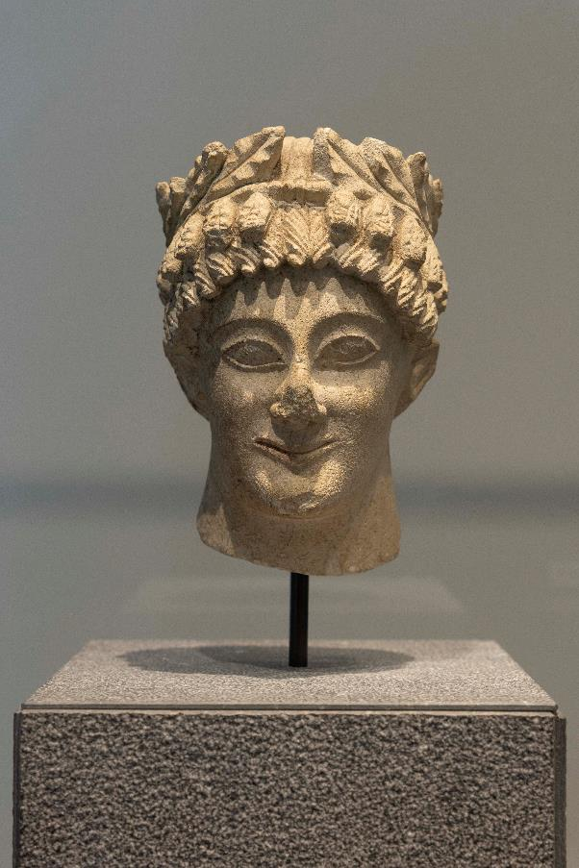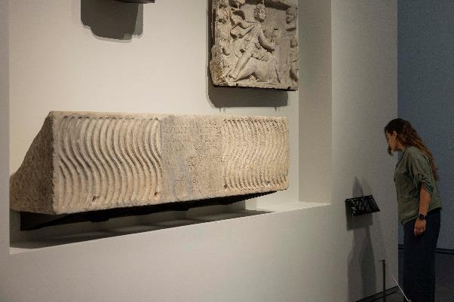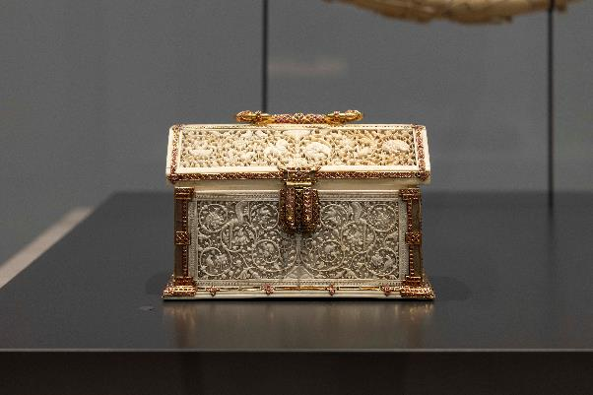
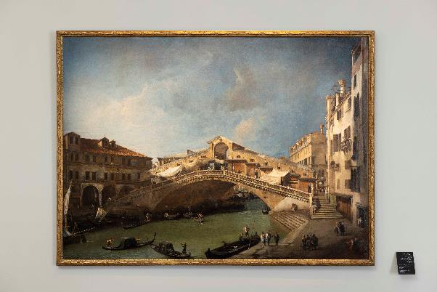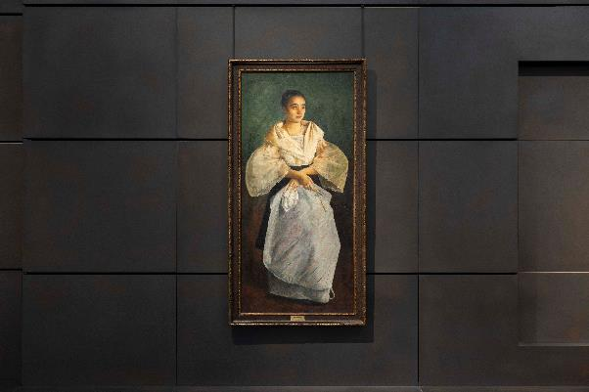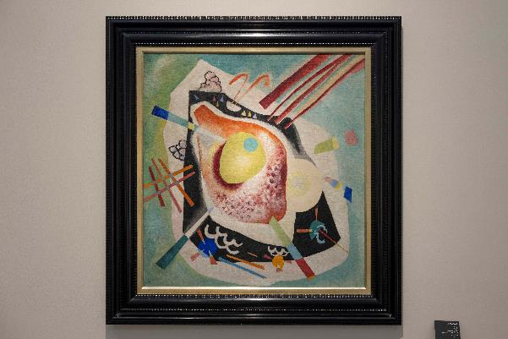
©Department of Culture and Tourism – Abu Dhabi. Photo: Seeing Things/Ismail Noor
Abu Dhabi, UAE – 9 July 2025 – There is always something new to discover at Louvre Abu Dhabi. Whether it is a first visit or a return for further exploration, the museum’s ever-evolving galleries promise hours of inspiration and wonder. This year, a new display brings together remarkable acquisitions and prestigious international loans. From a 1st-century imperial cameo and a 3rd-century Christian sarcophagus to an outstanding selection of paintings and modern works by Kandinsky, Giacometti and Tàpies, the artworks now on display span centuries, cultures and artistic movements. Together, they invite visitors to experience the museum’s universal narrative through the lens of creativity, connection and the enduring power of art.
“By continuously enriching Louvre Abu Dhabi’s collection through carefully curated acquisitions, we ensure that the museum remains a dynamic space that resonates with art enthusiasts, families and curious minds alike,” said Dr. Guilhem André, Director of Scientific, Curatorial and Collections Management at Louvre Abu Dhabi. “We are also thrilled to bring to our visitors loaned masterworks that are considered priceless treasures in their respective museums, and we are grateful for the generosity of our partners. This ongoing renewal strengthens Louvre Abu Dhabi’s role not only as a cultural anchor in the Saadiyat Cultural District, but also as a place where diverse stories and shared human experiences come together.”
The curatorial team at Louvre Abu Dhabi, particularly Amna Al Zaabi, Fakhera Alkindi, Aisha Al Ahmadi, Mariam Al Dhaheri, and Rawdha AlAbdouli, played a key role in developing the new displays, working closely with partner institutions on everything from research to securing loans and acquisitions. Their contributions reflect the museum’s commitment to empowering local talent and fostering cross-cultural exchange on a global scale.
New Acquisitions: Enriching the Museum’s Permanent Collection
Louvre Abu Dhabi continues to expand its world-class collection through the addition of exceptional artworks that reflect the museum’s universal narrative. The new acquisitions include significant paintings, sculptures and finely crafted objects that are now on display in the museum’s permanent galleries.
- A Kota Reliquary Figure from Gabon (end of 19th or beginning of 20th century) attributed to the Sébé River Master of the Skull Head resonates with global traditions of ancestor veneration and spiritual guardianship.
- A Roman Cameo possibly depicting Agrippa Postumus (c. 37-41 CE) is displayed alongside other masterpieces of precious gold jewelry from the museum’s collection.
- A limestone Head of an Ephebe (5th century BCE), from Cyprus is shown alongside other busts representing diverse cultures and civilisations.
- A Casket from the Kingdom of Kotte, Ceylon (ca. 1543) showcases hybrid aesthetics and reflects the global reach of South Asian courtly art.
- A collection of outstanding paintings including The Rialto Bridge from the South (c. 1720) by Giovanni Antonio Canal, capturing a serene, precise Venetian cityscape; The Farewell of Telemachus and Eucharis (1800), a rare Neoclassical painting by Charles Meynier exploring themes of duty, love and moral virtue; and a Portrait of Kosa Pan (1686) by Antoine Benoist, portraying the first ambassador from Siam to the French court of Louis XIV.
- Wassily Kandinsky’s White Oval (1921), a vibrant composition of colours and forms reflecting the artist’s strong belief in the power of colour, form and composition to evoke emotion, rhythm and unity.
New Loans: Masterpieces from International Partners
In addition to the newly unveiled acquisitions, unique masterpieces on loan from Musée du Louvre, Centre Pompidou and the National Museum of the Philippines bring fresh depth and global perspective to Louvre Abu Dhabi’s galleries. Highlights include:
- Sarcophagus of Livia Primitiva (c. 250 CE), a sculpture on loan from the Musée du Louvre, and one of the earliest known examples of Christian funerary art.
- Portrait of the Artist (1825) by French painter Antoinette Cécile Hortense Haudebourt-Lescot, on loan from the Musée du Louvre. In this painting, Haudebourt-Lescot presents herself firmly as a professional artist and emphasises her identity as a portraitist.
- Una Bulaqueña (1895), painted by Juan Luna, one of the most celebrated Filipino artists, is on loan from the National Museum of the Philippines. Leaving its home country for the first time, this painting was declared a National Cultural Treasure in 2008. It is celebrated not only for its technical excellence, but also for the sense of cultural pride it embodies, representing an idealised Filipina woman that radiates strength and dignity.
- Two bronze figures, introducing the theme of reimagining the human figure, are on loan from Centre Pompidou: Femme de Venise V (Woman of Venice V, 1956) by Alberto Giacometti is an elongated, fragile figure that captures the paradox of presence and vulnerability; and L’Orage (The Storm, 1947 – 1948) by Germaine Richier portrays a monumental male figure embodying resilience in the face of elemental forces.
- Grand blanc horizontal (1962), a monumental mixed-media work by Antoni Tàpies, is on loan from Centre Pompidou. The work adds a contemporary dimension to the museum’s narrative of material experimentation and abstraction.
Each new display at Louvre Abu Dhabi is curated to foster dialogue between civilisations, across time and through universal stories. Through thematic juxtapositions and cross-cultural comparisons, the museum continues to offer a dynamic and inclusive space for discovery for both first-time and returning visitors.
For more information about the galleries and to book tickets, please visit www.louvreabudhabi.ae or call Louvre Abu Dhabi at +971 600 56 55 66.
-Ends-
NOTES TO EDITORS
Louvre Abu Dhabi is open Tuesday – Sunday from 10 am – 6:30 pm; closed on Mondays. Pre-purchased tickets are required to visit the museum. E-tickets can be reserved via the museum’s website.
Follow Louvre Abu Dhabi on social media: Facebook (Louvre Abu Dhabi), Twitter (@LouvreAbuDhabi) and Instagram (@LouvreAbuDhabi) #LouvreAbuDhabi.
For more information on Louvre Abu Dhabi’s acquisitions policies and principles, visit our website.
ABOUT LOUVRE ABU DHABI
Created by an exceptional agreement between the governments of Abu Dhabi and France, Louvre Abu Dhabi was designed by Jean Nouvel and opened on Saadiyat Island in November 2017. The museum is inspired by traditional Islamic architecture and its monumental dome creates a rain of light effect and a unique social space that brings people together.

Louvre Abu Dhabi celebrates the universal creativity of mankind and invites audiences to see humanity in a new light. Through its innovative curatorial approach, the museum focuses on building understanding across cultures: through stories of human creativity that transcend civilisations, geographies, and times.

The museum’s growing collection is unparalleled in the region and spans thousands of years of human history, including prehistoric tools, artefacts, religious texts, iconic paintings, and contemporary artworks. The permanent collection is supplemented by rotating loans from 19 French partner institutions, regional and international museums.

Louvre Abu Dhabi is a testing ground for new ideas in a globalised world and champions new generations of cultural leaders. Its international exhibitions, programming and Children’s Museum are inclusive platforms that connect communities and offer enjoyment for all.

ABOUT MUSÉE DU LOUVRE
Open to all since 1793, the Musée du Louvre was the first museum to open to the general public in France. Born of the French Revolution and heir to the great royal collections, this former palace of the kings of France has always lived and evolved alongside national – and global – history.

Today, the Louvre is one of the leading players on the international museum scene, with its 30,000 works of art displayed across 70,000 square metres, including masterpieces like the Mona Lisa, the Winged Victory of Samothrace, the Seated Scribe and the Venus de Milo. It holds collections that tell a history of the world that has always been built on exchanges and connections, spanning from antiquity to the 19th century, from Asia to the Americas. The Louvre is a museum with a universal mission, a place where cultures and civilisations come together, where past and present interact. It is the place where all kinds of arts and all forms of expression manifest in today’s world – a place to better grasp the very aspirations of humanity.

ABOUT CENTRE POMPIDOU
Since 1977, the Centre Pompidou has remained a hub of vibrant and engaged culture—a multidisciplinary center deeply rooted in the city and open to the world. In 2025, the Centre Pompidou is starting a metamorphosis and will stay in motion during the renovation of the building, due to reopen in 2030. A rich programme will take place in the historic building until September 2025. From January 2025 onwards, the “Constellation” will reveal itself in Paris, France and internationally – while the Centre Pompidou Francilien–fabrique de l’art is in the works (opening in 2026).

ABOUT THE DEPARTMENT OF CULTURE AND TOURISM – ABU DHABI
The Department of Culture and Tourism – Abu Dhabi (DCT Abu Dhabi) drives the sustainable growth of Abu Dhabi’s culture and tourism sectors and its creative industries, fuels economic progress and helps achieve Abu Dhabi’s wider global ambitions. By working in partnership with the organisations that define the emirate’s position as a leading international destination, DCT Abu Dhabi strives to unite the ecosystem around a shared vision of the emirate’s potential, coordinate effort and investment, deliver innovative solutions, and use the best tools, policies, and systems to support the culture and tourism industries.

DCT Abu Dhabi’s vision is defined by the emirate’s people, heritage, and landscape. We work to enhance Abu Dhabi’s status as a place of authenticity, innovation, and unparalleled experiences, represented by its living traditions of hospitality, pioneering initiatives, and creative thought.

ABOUT SAADIYAT CULTURAL DISTRICT
Home to Louvre Abu Dhabi, Berklee Abu Dhabi, Manarat Al Saadiyat, Abrahamic Family House and the soon-to-open Zayed National Museum, teamLab Phenomena Abu Dhabi, Guggenheim Abu Dhabi and Natural History Museum Abu Dhabi, Saadiyat Cultural District is one of the greatest concentrations of cultural institutions.
Saadiyat Cultural District is a global platform, emanating from a rich cultural heritage, celebrating traditions, and advancing equitable culture. It is an embodiment of empowerment, showcasing museums, collections, and narratives that supports the region’s heritage while promoting a diverse global cultural landscape.
Saadiyat Cultural District is a testament to Abu Dhabi's commitment to preserving heritage while embracing a forward-looking vision. The District invites the world to engage with diverse cultures, fostering dialogue exchange, and offers a global cultural space that supports the region and the global South.

