Press Release—For press materials, please click here

Louvre Abu Dhabi & Richard Mille Announce Second Edition of Louvre Abu Dhabi Art Here
2022 and The Richard Mille Art Prize

- Jury panel will select artists for the Louvre Abu Dhabi Art Here 2022 exhibition, to run from November 2022 until February 2023
- One artist to be named The Richard Mille Art Prize 2022 winner
- This year the call for proposals is open to GCC artists (nationals and residents) until 31 July 2022; proposals can be submitted via Louvre Abu Dhabi’s website with the cash award increased to USD 60,000

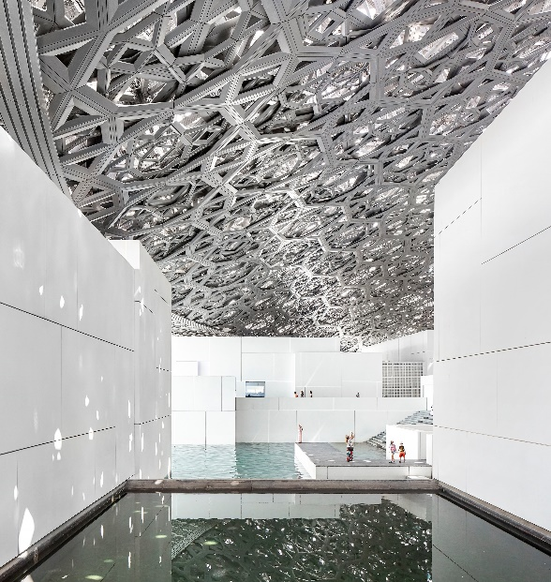

Abu Dhabi, UAE, 17 June 2022: To mark the museum’s fifth anniversary, Louvre Abu Dhabi and Swiss watchmaking brand Richard Mille have announced the second edition of the Louvre Abu Dhabi Art Here exhibition and the Richard Mille Art Prize, which will call on GCC artists (nationals and residents) working in various media to become part of its universal story - all of which will be showcased at the museum’s Forum, a space of interaction and exchange dedicated to contemporary art.

Curated by Reem Fadda, Director of Abu Dhabi’s Cultural Foundation, Louvre Abu Dhabi Art Here 2022 invites artists to propose new or existing artworks that engage with the notions of Icon and Iconic. Submissions will examine how the concept of the icon resonates within contemporary art practices and how it informs new artistic perspectives.

In an increasingly digitised world, the terms ‘icon’ and ‘iconic’ often connect and separate – an icon is at once an object, an image, and a symbol. Its iconic nature is derived from its visual impact on the viewer. For Louvre Abu Dhabi Art Here 2022, artists will be encouraged to re-engage with the icon to revitalise this iconic effect.

Shortlisted artists will showcase their work in the Louvre Abu Dhabi Art Here 2022 exhibition, on display from November 2022 until February 2023 in the museum’s Forum. From these shortlisted artists, the jury will select one recipient of The Richard Mille Art Prize 2022. Proposals for the open call may be submitted until 31 July 2022 via the Louvre Abu Dhabi website.

The 2022 jury members are HH Sheikh Zayed bin Sultan bin Khalifa Al Nahyan, Chairman of UAE Unlimited, an art collector and patron of the Centre Pompidou, the British Museum, and Sharjah Art Foundation; Christine Macel, the chief curator at the Musée national d’art moderne, Centre Pompidou, and an art critic; Hala Wardé, founding architect of HW Architecture , long-term partner of Jean Nouvel and the lead of the Louvre Abu Dhabi project; Dr. Souraya Noujaim, Director of Scientific, Curatorial and Collections Management at Louvre Abu Dhabi; and Reem Fadda, Director of the Cultural Foundation and the curator of Louvre Abu Dhabi Art Here 2022.

Manuel Rabaté, Director of Louvre Abu Dhabi, said: “As part of Louvre Abu Dhabi’s ongoing 5th anniversary celebrations, we are delighted to announce the second edition of Louvre Abu Dhabi Art Here 2022 in partnership with Swiss watchmaking brand Richard Mille. This year’s exhibition and prize seek to illuminate the notions of ‘Icon’ and ‘Iconic’, complementing the museum’s development and success throughout these past five years. As part of a mutual, long-term commitment with Richard Mille, Louvre Abu Dhabi continues its mission of championing contemporary artistic talent within the UAE and the GCC, while connecting the museum to its territory.”

Peter Harrison, CEO of Richard Mille EMEA, said: “We are honoured to be expanding the Richard Mille Art Prize 2022 opportunity to GCC nationals and residents, as we celebrate the 5th anniversary of Louvre Abu Dhabi. Following last year’s impressive roster of artists, this year’s edition of the Richard Mille Art Prize challenges artists to reflect on the powerful terms: Icon and Iconic, advancing the confines of their creativity. We stay committed to supporting regional artists, reinforcing our avid admiration for the world of contemporary art.”

Dr. Souraya Noujaim, Director of Scientific, Curatorial and Collections Management at Louvre Abu Dhabi, said: “In honour of the museum’s 5th anniversary, Louvre Abu Dhabi Art Here 2022 will invite GCC artists, both nationals and residents, to focus on the notions of ‘Icon’ and ‘Iconic’ by not merely celebrating the past, but rooting and contextualising contemporary art in its present form. Contemporary art is often said to challenge the elevated, iconic status of art. But in Louvre Abu Dhabi, where the human story of our shared experience of objects, images, and symbols is told in all its richness and depth, this relationship is redefined. Under the museum’s dome, contemporary artists are asked to not simply reinterpret or repeat; instead, they are encouraged to re-engage with the icon to revitalise its iconic effect. We are very delighted to introduce the second edition of this extraordinary opportunity in partnership with Richard Mille, celebrating Louvre Abu Dhabi’s ongoing effort to showcase contemporary art and highlight our unceasing dedication to creating a platform for artistic talent.”

With the success of the inaugural edition of Louvre Abu Dhabi Art Here 2021 and the Richard Mille Art Prize, Louvre Abu Dhabi and Richard Mille continue to foster the region’s booming art scene by giving local artists, such as Bahraini-American artist Nasser Alzayani, winner of the Richard Mille Art Prize 2021, a platform to be seen and heard. Alzayani was one of seven artists shortlisted for the award in October 2021 and showcased his work in the Louvre Abu Dhabi Art Here 2021 exhibition.

For more information about Louvre Abu Dhabi Art Here 2022 and The Richard Mille Art Prize, please visit https://www.louvreabudhabi.ae/en/Explore/art-here-2022

-ENDS-

ABOUT LOUVRE ABU DHABI
Created by an exceptional agreement between the governments of Abu Dhabi and France, Louvre Abu Dhabi was designed by Jean Nouvel and opened on Saadiyat Island in November 2017. The museum is inspired by traditional Islamic architecture and its monumental dome creates a rain of light effect and a unique social space that brings people together.

Louvre Abu Dhabi celebrates the universal creativity of mankind and invites audiences to see humanity in a new light. Through its innovative curatorial approach, the museum focuses on building understanding across cultures: through stories of human creativity that transcend civilisations, geographies and times.

The museum’s growing collection is unparalleled in the region and spans thousands of years of human history, including prehistoric tools, artefacts, religious texts, iconic paintings, and contemporary artworks. The permanent collection is supplemented by rotating loans from 13 French partner institutions, regional, and international museums.

Louvre Abu Dhabi is a testing ground for new ideas in a globalised world and champions new generations of cultural leaders. Its international exhibitions, programming and Children’s Museum are inclusive platforms that connect communities and offer enjoyment for all.

ABOUT RICHARD MILLE
From the very inception of the brand in 2001, Richard Mille’s approach to watchmaking has always centered on releasing the watch from it restricted role as a mere tool for timekeeping, augmenting and extending its visual potential by placing it directly in the crosshairs of design, art and architecture. Today, the Richard Mille watch collection comprises of more than eighty models, each designed and produced with the same passion, uncompromising principles and visionary aesthetics that guided Richard Mille’s first creation.

Richard Mille’s watches are marvels of technology designed specifically for those with a keen appreciation and love for fine Swiss watchmaking, playing up the full possibilities of three-dimensional space, defined by both the volume of the watchcase and the movement itself. Within these highly confined areas spanning just a few centimetres that serve as a blank canvas for horological creativity.

This assimilation of watchmaking to artistic endeavours is also reflected in the company’s close connections with the arts. The brand’s partnerships in support of contemporary art and artists include sponsorship of the Palais de Tokyo in Paris, the contemporary art biennial Desert X; collaborations with choreographer Benjamin Millepied, composer Thomas Roussel and acquisition of Éditions Cercle d’Art, a publishing house created with the support of Pablo Picasso in the 1950s.

For more about Richard Mille please visit richardmille.com

ABOUT THE DEPARTMENT OF CULTURE AND TOURISM – ABU DHABI
The Department of Culture and Tourism – Abu Dhabi (DCT Abu Dhabi) drives the sustainable growth of Abu Dhabi’s culture, tourism and creative sectors, fuels economic progress, and helps achieve Abu Dhabi’s wider global ambitions. By working in partnership with the organisations that define the emirate’s position as a leading international destination, DCT Abu Dhabi strives to unite the ecosystem around a shared vision of the emirate’s potential, coordinate effort and investment, deliver innovative solutions, and use the best tools, policies, and systems to support the culture and tourism industries.

DCT Abu Dhabi’s vision is defined by the emirate’s people, heritage, and landscape. We work to enhance Abu Dhabi’s status as a place of authenticity, innovation, and unparalleled experiences, represented by its living traditions of hospitality, pioneering initiatives, and creative thought.

