Press Release
For full press kit, please click here

Louvre Abu Dhabi’s New Exhibition, Stories of Paper, Opens to the Public
Organised in partnership with Musée du Louvre and France Muséums
About 100 artworks from the collections of Louvre Abu Dhabi, Musée du Louvre and 14 lending museums, institutions, and private collections
20 April — 24 July 2022
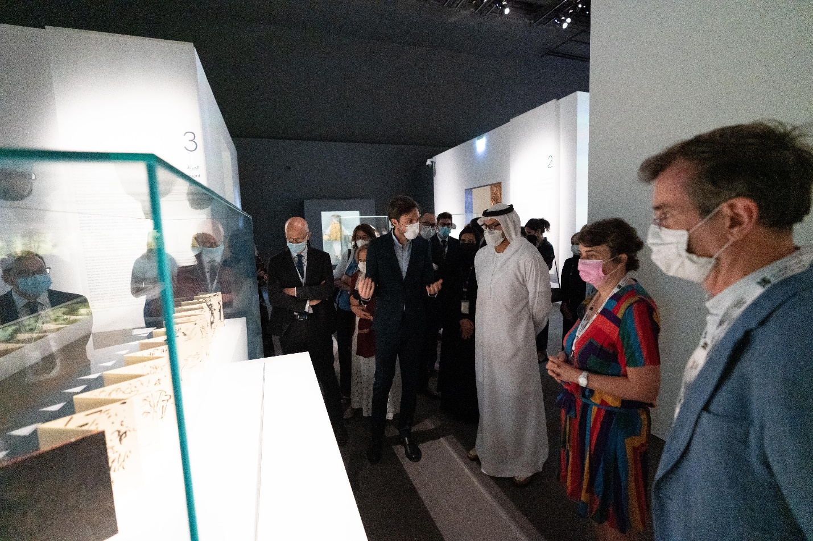
H.E. Mohamed Khalifa Al Mubarak, Chairman of the Department of Culture and Tourism – Abu Dhabi,
on a tour of the Stories of Paper exhibition at Louvre Abu Dhabi
© Department of Culture and Tourism–Abu Dhabi

Abu Dhabi, 19 April 2022: H.E. Mohamed Khalifa Al Mubarak, Chairman of the Department of Culture and Tourism – Abu Dhabi, inaugurated Louvre Abu Dhabi’s second international exhibition of the year, Stories of Paper. The all-new exhibition will open to the public on April 20 and will run until July 24, 2022. Organised by Louvre Abu Dhabi in partnership with Musée du Louvre and France Muséums, the exhibition discovers the extensive variety of artistic expressions of paper, with the purpose of encouraging richer knowledge of a familiar, and increasingly versatile material.

Stories of Paper is curated by the Musée du Louvre’s Xavier Salmon, General Curator and Director of the Department of Drawings and Prints, and Victor Hundsbuckler, Curator at the Department of Drawings and Prints, with the support of Dr. Souraya Noujaim, Director of Scientific, Curatorial and Collections Management at Louvre Abu Dhabi. The curators were assisted by Amna Rashed Al Zaabi, Senior Curatorial Assistant, Louvre Abu Dhabi, Charlotte Maury, Art Collection Officer, Department of Islamic Art, Musée du Louvre and Cristina Cramerotti, Musée National des Arts Asiatiques – Guimet.

About 100 artworks and objects from 16 museums, cultural institutions and private collections will be on display. These include books, manuscripts, drawings, a reproduction of a house and 13 contemporary artworks and installations made of paper. The exhibition will take visitors on a journey through time to discover the various ways in which paper was utilised across cultures. Visitors will also be able to enjoy a diverse public programme of wide-ranging cultural activities.

Manuel Rabaté, Director of Louvre Abu Dhabi, said: “With the emergence of digital transformation and the dematerialization of our haptic experiences, it makes sense for Louvre Abu Dhabi, a universal museum, to celebrate paper as a common yet precious good. From books, manuscripts and drawings to contemporary art works or installations made of paper, Stories of Paper retraces a chronological history of this single universal medium, considering the usage and key characteristics of paper such as transparency and robustness to provide an original perspective on the use of paper throughout time and across the different regions. We are also very pleased to invite prominent Emirati artists to be to be part of this shared dialogue—with works on display by Hassan Sharif, Abdullah Al Saadi and Mohammed Kazem, all of whom are considered pioneers of Emirati conceptual art. A special thanks goes to Musée du Louvre, France-Muséums and all the international lending institutions and private collections who have helped in bringing this exhibition to fruition.”

Laurence des Cars, Director of Musée du Louvre, said: “Stories of Paper exhibition includes a rich selection of loans from Musée du Louvre, Musée Guimet, Bibliothèque Nationale de France, Centre Pompidou, Bibliothèque Nationale et Universitaire de Strasbourg, Bibliothèque Sainte-Geneviève, Sharjah Art Foundation, Zayed National Museum, and Goesan Museum, as well as works from the permanent collection of Louvre Abu Dhabi. It fuses contemporary works from Arab and European art scenes, such as Labyrinth by the great Italian artist Michelangelo Pistoletto—a piece which confirms papers perpetual importance to mankind. This is precisely where the essence of Louvre Abu Dhabi lies—in its ability to bring together diverse collections that would probably not have had the opportunity to interact anywhere else but in Louvre Abu Dhabi.”

Stories of Paper spans 12 themed sections, all of which highlight the key qualities and varied use of paper across centuries with immersive scenography. The themed sections include Plant Origins, An Affordable, Widely Used and Multipurpose Material, Movement, Colour, Transparency and Translucency, A Versatile Material, a Substitute Material, A Support for Reproducing Works, Fragility and Resistance, A Space, A Possibility of Collecting, A Space of Annotating, of Associating Comments and Images, a Trace and a Malleable Support. The exhibition will allow the visitors to understand the tools and mechanisms used to create paper, and also invite them to explore the different textures of paper through the mediation devices.

Curators Xavier Salmon and Victor Hundsbuckler said: “Stories of Paper is exhibited in parallel to the UAE’s great appetite for contemporary creation and innovative technologies, with the ambition to create curiosity for this familiar material at a time when digital technology is permeating all aspects of our daily lives. The exhibition aims to establish this definition using 12 criterions and taking a historical look at paper on a global scale. Beyond drawings, this exhibition explores the whole range of artistic expressions of paper with the aim of encouraging wonder and fostering the visitor’s understanding of an ordinary yet extremely versatile medium.”

Dr. Souraya Noujaim, Scientific, Curatorial and Collections Management Director at Louvre Abu Dhabi, said: “Paper has, without a doubt, served a purpose in every aspect of society throughout history. There is already nostalgia for the material and its many familiar uses in our daily lives. However, time is not up for paper. It is still strongly rooted in our practices and its charm has not faded. This is evident in the artworks on display at Stories of Paper. We are very proud that, for the first time, we are able to showcase pieces from renowned Emirati contemporary artists, such as Hassan Sharif, Abdullah Al Saadi and Muhammad Kazem, which explore key attributes of paper as a medium, celebrating this simple yet unique medium and its perpetual importance in today’s society.”

Cultural and Educational Programme

A rich cultural and educational programme will accompany Stories of Paper, offering an array of events. An online talk and a recorded podcast by the exhibition’s curators will be available on Louvre Abu Dhabi’s website and mobile application, for the public to explore the exhibition.

In collaboration with Cinema Akil, Berklee Abu Dhabi, Goethe institute, Irtijal, and Metropolis Art Cinema, Louvre Abu Dhabi will present a cine-concert on May 4, fusing two worlds by presenting contemporary electronic experimental music from the Arab world, in synchronised harmony and improvisation against the silent film classic, The Adventures of Prince Achmed, directed by Lotte Reiniger. Film screening will provide enjoyable, accessible, and diverse viewing experiences, with stories from cultures around the world. A series of films featuring paper as a medium will be screened on May 5: Kubo and the Two Strings, featuring a 12-year-old Japanese boy earning his living by magically manipulating origami with music (the film will be followed by a sketching session for children and families); and three short films (The Dot, Sky Color, and ISH), inspiring kids to create their own dots, squiggles and much more.

A series of educational activities will be available for adults, families, and youth including an Express Tour of the exhibition, a creative masterclass using paper and print focusing on an abstract representation of ideas, led by an Emirati artist, and, a Make and Play activity where children can experiment with different kinds of paper to make a paper portrait and other objects, and a Young Visitor’s Guide offering the opportunity to learn about the properties and stories of paper throughout history. An online papermaking masterclass with Emirati artist Taqwa Al Naqbi will teach participants how to make their own handmade paper, inspired by the Qur’an commissioned by Sultan Abdullah II Al Sa'adi, and enjoy with the family a Make a Plant illustration activity.

The Stories of Paper exhibition catalogue is available in Arabic, English and French.

For more information about the exhibition and to book tickets, please visit www.louvreabudhabi.ae or call Louvre Abu Dhabi at +971 600 56 55 66. Entrance to the exhibition is free with the museum’s general admission tickets. Admission to the museum is free for children under the age of 18.

-END-

NOTES TO EDITORS
Louvre Abu Dhabi is open Tuesday – Sunday from 10 am – 6:30 pm; closed on Mondays. Pre-purchased tickets are required to visit the museum. E-tickets can be reserved via the museum’s website.

Ramadan and Eid timing: Louvre Abu Dhabi will open from 10 am until midnight from April 21 until the end of Eid Al Fitr.

Follow Louvre Abu Dhabi on social media: Facebook (Louvre Abu Dhabi), Twitter (@LouvreAbuDhabi) and Instagram (@LouvreAbuDhabi) #LouvreAbuDhabi.

For more information on Louvre Abu Dhabi’s acquisitions policies and principles, visit our website.
Louvre Abu Dhabi has been certified as a “Go-Safe” site. Our partnership with VPS Healthcare means that the health and wellbeing of our visitors will be prioritized throughout their visit, from timed ticketing to temperature checks, to the ample space to social distance throughout the galleries and outdoor spaces of the museum.

ABOUT LOUVRE ABU DHABI
Created by an exceptional agreement between the governments of Abu Dhabi and France, Louvre Abu Dhabi was designed by Jean Nouvel and opened on Saadiyat Island in November 2017. The museum is inspired by traditional Islamic architecture and its monumental dome creates a rain of light effect and a unique social space that brings people together.

Louvre Abu Dhabi celebrates the universal creativity of mankind and invites audiences to see humanity in a new light. Through its innovative curatorial approach, the museum focuses on building understanding across cultures: through stories of human creativity that transcend civilisations, geographies and times. The museum’s growing collection is unparalleled in the region and spans thousands of years of human history, including prehistoric tools, artefacts, religious texts, iconic paintings and contemporary artworks. The permanent collection is supplemented by rotating loans from 13 French partner institutions, regional and international museums.

Louvre Abu Dhabi is a testing ground for new ideas in a globalised world and champions new generations of cultural leaders. Its international exhibitions, programming and Children’s Museum are inclusive platforms that connect communities and offer enjoyment for all.

ABOUT FRANCE MUSÉUMS
Following the intergovernmental agreement between France and the Emirates of Abu Dhabi signed in 2007, France Muséums, a cultural consulting and engineering agency, was created to work towards the creation of Louvre Abu Dhabi and support the project in all its dimensions (strategic, scientific, cultural, building, human resources).

Since the opening of the UAE museum in 2017, France Muséums continues to support Louvre Abu Dhabi in four main fields of activity: the management and coordination of loans from French museums for the permanent galleries of the museum, the organisation and production of 4 international exhibitions per year, training of teams and a wide range of consultancy and auditing assignments in all areas of museum management.

France Muséums mobilise its teams based in Paris and Abu Dhabi and a network of 17 major French cultural institutions and museum partners : Musée du Louvre, Centre Pompidou, Musées d’Orsay et de l’Orangerie, Bibliothèque nationale de France, Musée du quai Branly-Jacques Chirac, Réunion des Musées Nationaux et du Grand Palais (RMN-GP), Château de Versailles, Musée national des arts asiatiques-Guimet, Musée de Cluny – musée national du Moyen-Âge, École du Louvre, Musée Rodin, Domaine National de Chambord, Musée des Arts Décoratifs (MAD), Cité de la Céramique – Sèvres & Limoges, Musée d’Archéologie nationale – Saint-Germain en Laye, Château de Fontainebleau, and OPPIC (Opérateur du patrimoine et des projets immobiliers de la culture), le musée de l’Armée et le Musée des Beaux-Arts de Lyon.

ABOUT MUSÉE DU LOUVRE
The Louvre in Paris opened in 1793, during the French Revolution, and from the very beginning was intended to provide inspiration for contemporary art. Courbet, Picasso, Dalí and so many others came to its hallowed halls to admire the old masters, copy them, immerse themselves in masterpieces and improve and fuel their own art. As an ancient royal residence, the Louvre is inextricably linked to eight centuries of French history. As a universal museum, its collections, among the best in the world, span many millennia and miles, from the Americas to Asia. Over 38,000 artworks are grouped into eight curatorial departments, including universally admired works such as the Mona Lisa, the Winged Victory of Samothrace and the Venus de Milo. With 9.6 million guests in 2019, the Louvre is the most visited museum in the world.

The Department of Drawings and Prints is home to 190,000 works including drawings, pastels, miniatures, prints, books, manuscripts, autograph works, woodcuts, copperplates, and lithographic stones. The particularity of the Department of Prints and Drawings stems from a characteristic of the works in its care: their technical fragility and sensitivity to light prevent their permanent display. As a result, the department is organized like a library; the works are kept in storerooms, and only taken out for viewing in the reference room or for exhibitions subject to strict conditions: a maximum duration of three months, an illumination of 50 lux on the surface of the object, a temperature of 20°C, a relative humidity of 50%, and a subsequent rest period of three years.

ABOUT SAADIYAT CULTURAL DISTRICT
Saadiyat Cultural District on Saadiyat Island, Abu Dhabi, is devoted to culture and the arts. An ambitious cultural undertaking for the 21st century, it will be a nucleus for global culture, attracting local, regional and international guests with unique exhibitions, permanent collections, productions and performances. Its ground-breaking buildings will form a historical statement of the finest 21st century architecture; Zayed National Museum, Louvre Abu Dhabi and Guggenheim Abu Dhabi. These museums will complement and collaborate with local and regional arts and cultural institutions including universities and research centres.

ABOUT THE DEPARTMENT OF CULTURE AND TOURISM – ABU DHABI
The Department of Culture and Tourism – Abu Dhabi (DCT Abu Dhabi) drives the sustainable growth of Abu Dhabi’s culture, tourism and creative sectors, fuels economic progress and helps achieve Abu Dhabi’s wider global ambitions. By working in partnership with the organisations that define the emirate’s position as a leading international destination, DCT Abu Dhabi strives to unite the ecosystem around a shared vision of the emirate’s potential, coordinate effort and investment, deliver innovative solutions, and use the best tools, policies and systems to support the culture and tourism industries.

DCT Abu Dhabi’s vision is defined by the emirate’s people, heritage and landscape. We work to enhance Abu Dhabi’s status as a place of authenticity, innovation, and unparalleled experiences, represented by its living traditions of hospitality, pioneering initiatives and creative thought.

