Press Release
Louvre Abu Dhabi’s first 2022 international exhibition Versailles & the World explores French royal court of ‘Sun King’ Louis XIV
Exhibition to run from 26 January – 4 June 2022 in partnership with Musée National des Châteaux de Versailles et de Trianon
Showcase of more than 100 masterpieces from the Louvre Abu Dhabi permanent
collection and a host of international lenders
Versailles explored as a place of international encounter and artistic production that looked to the wider world for inspiration while serving as a showcase for the finest French taste, craftsmanship, and art de vivre

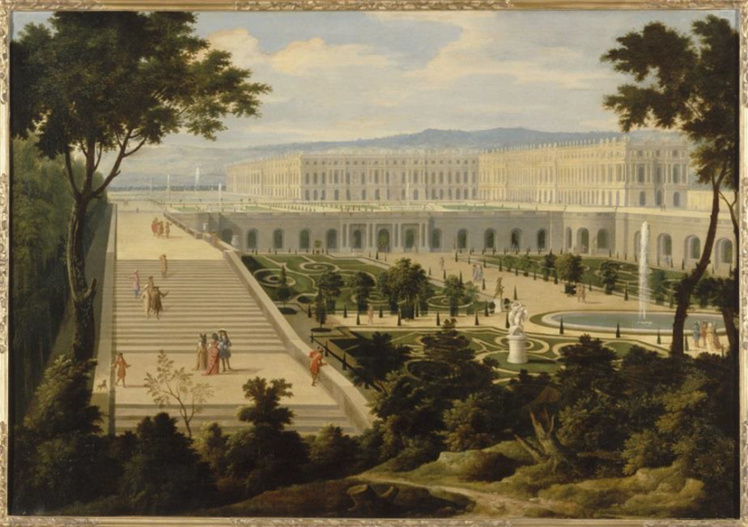
View from the Versailles palace from the Orangerie side
1695, oil on canvas, MV 6812, Château de Versailles
© Château de Versailles, Dist. RMN / © Christophe Fouin

Abu Dhabi, XX January 2022: Louvre Abu Dhabi has announced its first international exhibition of 2022, Versailles & the World, which will run from 26 January 2022 until 4 June 2022. Organised in partnership with Musée national des châteaux de Versailles et de Trianon, with the support of France Muséums, the exhibition will showcase the history of the royal court at Versailles.

Visitors will explore more than 100 artworks from the collections of Louvre Abu Dhabi, the UK’s Royal Collection Trust, and 17 French lenders including the Musée National des Châteaux de Versailles et de Trianon, alongside a wide-ranging cultural programme.

In the 17th century the Palace of Versailles, the greatest legacy of the ‘Sun King’ Louis XIV (1638-1715 CE), became the world’s most opulent royal playground, its size and splendour reflecting the king’s absolute power and influence. Louis XIV spent a remarkable 72 years on the throne and during this time he succeeded in turning France into the most powerful state in Europe and the Palace of Versailles into an international symbol of French sophistication and prestige.

By focusing on the reception, interpretation and appropriation of foreign cultures by the court in an era of scientific emulation, the exhibition will also explore how the Palace of Versailles became a crucible for intellectual encounter and cultural exchange between the French monarchy, the court, and foreign ambassadors and diplomatic missions during the reign of three French monarchs: Louis XIV, Louis XV and Louis XVI.

Versailles & the World is curated by Hélène Delalex, Heritage Curator and Bertrand Rondot, Chief Heritage Curator at the Department of Furniture and Decorative Arts at the Musée national des Châteaux de Versailles et de Trianon, with the support of Dr. Souraya Noujaim, Louvre Abu Dhabi’s Scientific, Curatorial and Collections Management Director.
Manuel Rabaté, Director of Louvre Abu Dhabi, said: “We are delighted to collaborate once again with our French partners for our first international exhibition of 2022 with Versailles & the World. This exhibition sheds new light on the complex network of diplomacy, commerce and creativity that helped shape the culture of a globalising age. It is a pleasure to highlight synergies between the historical role played by the Palace of Versailles, a place where people from different cultures came together, and Louvre Abu Dhabi, a museum dedicated to exploring and celebrating the diverse cultures of the world in our capital city of the UAE.”

Co-curators Hélène Delalex and Bertrand Rondot said: “Curiosity was the driving force at Versailles in the 17th and 18th centuries. Countries beyond Europe were seen as places of wonder but also of scientific discovery. This fascination often expressed itself most eloquently in the fine and decorative arts where ideas and motifs were appropriated, not just from the Islamic and oriental worlds, but from other European nations such as England and Italy.”

Dr. Souraya Noujaim, Scientific, Curatorial and Collections Management Director at Louvre Abu Dhabi, said: “In this exhibition, Louvre Abu Dhabi invites visitors to discover the court at Versailles and its vistas onto the wider world. Designed for those who are familiar with Versailles and those who are not, it shows how the arts were inspired by other lands and reflects the French court’s fascination with those distant countries, as well as the ambivalent, even competitive relations it had with them.”

The exhibition’s narrative is presented in three chapters:

A Palace Open to the World: Visitors of Versailles

Louis XIV made Versailles a theatre of daily spectacle for all his courtiers, subjects, and visitors from around the world. Detailed accounts of the receptions given to foreign ambassadors were published alongside images of their outfits, customs, and appearance, helping to diffuse a taste for the exotic in fashionable society.

The Orient Revealed and the Orient as a Reverie: Exoticism in Versailles

From the first years of Louis XIV’s reign, the taste for exoticism spread through the French court, fuelled by the literature and the stories of travellers who had ventured into the Ottoman Empire, Africa, America and Asia. This attraction reached its peak between 1704 and 1717 following the French translation by Antoine Galland (1646–1715) of the Thousand and One Nights, and can be seen in the popularity of fashionable styles such as chinoiserie and turquerie, inspired by the cultures of China and the Ottoman Empire. The general taste for turqueries in the 1770s led to the creation of several Turkish boudoirs at the court, one of the most famous being that of Marie-Antoinette at Versailles, which was laid out between 1774-1776.

Between Heaven and Earth: Discovering the World

The European fascination with foreign cultures coincided with a phase of history which saw the European gaze becoming increasingly global. The Ancient Regime was a time of great exploration, spurred in part by the rivalry between European nations. Commissioned and encouraged by Louis XIV, seaborne expeditions set sail to distant lands and oceans in search of new geographical, botanical, wildlife, cartographic, and astronomical discoveries while inspiring artists and artisans alike.

The objects in the exhibition, which include around 30 paintings, over 40 works on paper, books and manuscripts, sculptures, and numerous pieces of decorative art such as porcelain, tableware, silverware, gilt bronze, and furniture, have been loaned from France, the United Arab Emirates, and the United Kingdom.

-END-

Notes to editors

Louvre Abu Dhabi is open Tuesday – Sunday from 10 am – 6:30 pm; closed on Mondays. Pre-purchased tickets are required to visit the museum. E-tickets can be reserved via the museum’s website.

Follow Louvre Abu Dhabi on social media: Facebook (Louvre Abu Dhabi), Twitter (@LouvreAbuDhabi) and Instagram (@LouvreAbuDhabi) #LouvreAbuDhabi.

For more information on Louvre Abu Dhabi’s acquisitions policies and principles, visit our website.
Louvre Abu Dhabi has been certified as a “Go-Safe” site. Our partnership with VPS Healthcare means that the health and wellbeing of our visitors will be prioritized throughout their visit, from timed ticketing to temperature checks, to the ample space to social distance throughout the galleries and outdoor spaces of the museum.

About Louvre Abu Dhabi

Created by an exceptional agreement between the governments of Abu Dhabi and France, Louvre Abu Dhabi was designed by Jean Nouvel and opened on Saadiyat Island in November 2017. The museum is inspired by traditional Islamic architecture and its monumental dome creates a rain of light effect and a unique social space that brings people together.

Louvre Abu Dhabi celebrates the universal creativity of humanity through its unique curatorial strategy, which explores stories of cultural connections. Through its innovative approach, the museum focuses on building understanding across cultures: through episodes of human creativity that transcend culture, geography, and time.

The museum’s growing collection is unparalleled in the region and spans thousands of years of human history, including prehistoric tools, artefacts, religious texts, iconic paintings and contemporary artworks. The permanent collection is supplemented by rotating loans from 13 French partner institutions, regional and international museums.

Louvre Abu Dhabi is a testing ground for new ideas in a globalised world and champions new generations of cultural leaders. Its international exhibitions, programming and Children’s Museum are inclusive platforms that connect communities and offer enjoyment for all.

About the Château de Versailles
The Palace of Versailles, a famous world heritage site listed by UNESCO since 1979, is at the same time a royal residence, a museum of the history of France created by King Louis-Philippe and a national palace that has played host to the French Parliament in Congress.
Besides its three historic residences - the Palace, the Grand Trianon, and the Petit Trianon - the estate of Versailles boasts a large Baroque garden designed by André Le Nôtre with groves and fountains, the gardens of Trianon and Marie-Antoinette’s Hamlet, a wooded park located beyond the Grand Canal, and the royal estate of Marly since 2009.
Covering more than 800 hectares, the estate of Versailles welcomes visitors to admire its collections, which are composed of more than 60,000 works including paintings, furniture, ancient books, drawings, sculptures, prints, objets d’art and coaches. The former royal residence stands as testament to the history of France from the 17th century to the present day and is a symbol of French art de vivre, taste, and craft skills. It is forever anchored in the present thanks its patronage of contemporary creativity through its programme of shows, contemporary art exhibitions, and the promotion of the crafts etc., the Palace of Versailles’ reputation continues to grow and resonate internationally.
http://en.chateauversailles.fr/

About France Muséums

Following the intergovernmental agreement between France and Abu Dhabi signed in 2007, France Muséums, a cultural consulting and engineering agency, was created to work towards the creation of Louvre Abu Dhabi and support the project in all its dimensions (strategic, scientific, cultural, building, human resources).

Since the opening of the UAE museum in 2017, France Muséums has continued to support Louvre Abu Dhabi in four main fields of activity: the management and coordination of loans from French museums for the permanent galleries of the museum, the organisation and production of 4 international exhibitions per year, training of teams and a wide range of consultancy and auditing assignments in all areas of museum management.

France Muséums mobilises its teams based in Paris and Abu Dhabi and a network of 17 major French cultural institutions and museum partners including: Musée du Louvre, Centre Pompidou, Musées d’Orsay et de l’Orangerie, Bibliothèque nationale de France, Musée du quai Branly-Jacques Chirac, Réunion des Musées Nationaux et du Grand Palais (RMN-GP), Château de Versailles, Musée national des arts asiatiques-Guimet, Musée de Cluny – musée national du Moyen-Âge, École du Louvre, Musée Rodin, Domaine National de Chambord, Musée des Arts Décoratifs (MAD), Cité de la Céramique – Sèvres & Limoges, Musée d’Archéologie nationale – Saint-Germain en Laye, Château de Fontainebleau, and OPPIC (Opérateur du patrimoine et des projets immobiliers de la culture), le musée de l’Armée et Musée des Beaux-Arts de Lyon.
About the Saadiyat Island Cultural District

The Saadiyat Cultural District on Saadiyat Island, Abu Dhabi, is devoted to culture and the arts. An ambitious cultural undertaking for the 21st century, it will be a nucleus for global culture, attracting local, regional and international guests with unique exhibitions, permanent collections, productions and performances. Its ground-breaking buildings will form a historical statement of the finest 21st century architecture: Zayed National Museum, Louvre Abu Dhabi and Guggenheim Abu Dhabi. These museums will complement and collaborate with local and regional arts and cultural institutions including universities and research centres.

About the Department of Culture and Tourism – Abu Dhabi (DCT Abu Dhabi)

The Department of Culture and Tourism – Abu Dhabi (DCT Abu Dhabi) drives the sustainable growth of Abu Dhabi’s culture and tourism sectors, fuels economic progress and helps achieve Abu Dhabi’s wider global ambitions. By working in partnership with the organisations that define the emirate’s position as a leading international destination, DCT Abu Dhabi strives to unite the ecosystem around a shared vision of the emirate’s potential, coordinate effort and investment, deliver innovative solutions, and use the best tools, policies and systems to support the culture and tourism industries. DCT Abu Dhabi’s vision is defined by the emirate’s people, heritage and landscape. We work to enhance Abu Dhabi’s status as a place of authenticity, innovation, and unparalleled experiences, represented by its living traditions of hospitality, pioneering initiatives and creative thought.

