Exhibition of 20th century Modern masterpieces opens at Louvre Abu Dhabi on 18 September
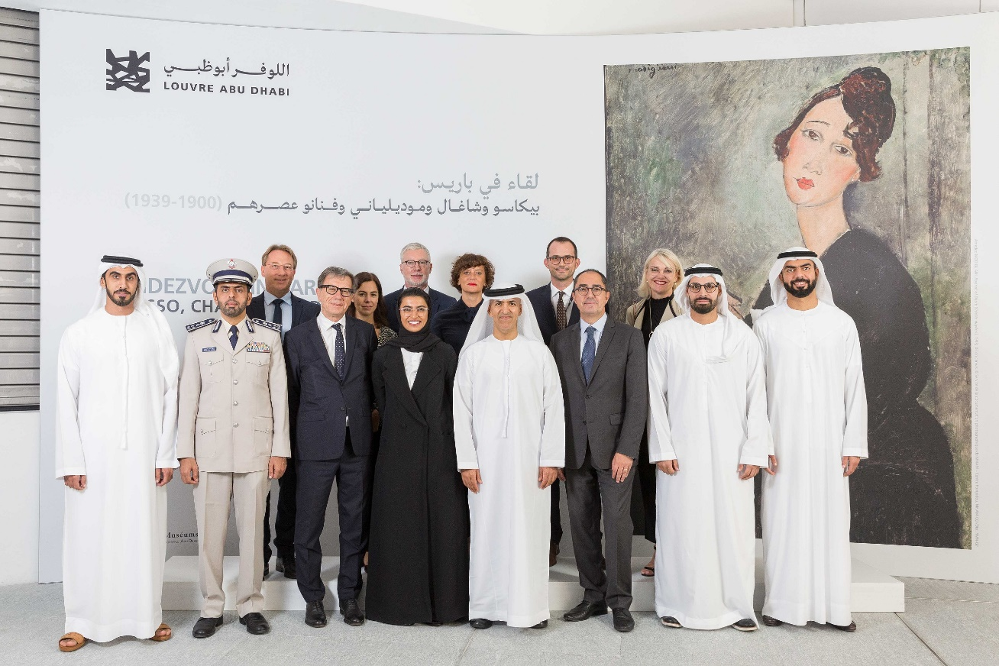
The exhibition was inaugurated by HE Noura bint Mohammed Al Kaabi, Minister of Culture and Knowledge Development and HE Mohamed Khalifa Al Mubarak, Chairman of the Department of Culture and Tourism – Abu Dhabi and was attended by H.E. Dr. Mugheer Khamis Al Khaili Chairman of the Department of Community Development, HE Saif Saeed Ghobash, Undersecretary of the Department of Culture and Tourism - Abu Dhabi, HE Mubarak Al-Nakhi, Undersecretary of the Ministry of Culture and Knowledge Development, Brigadier Suhail Saeed Al Khaili, Director of Central Operations at Abu Dhabi Police, HE Ludovic Pouille, Ambassador of France to the UAE, Manuel Rabaté, Director of Louvre Abu Dhabi, Serge Lasvignes, President of Centre Pompidou, Jean-Luc Martinez, President Director of Musée du Louvre, Anne Mény-Horn, Chief Executive Officer of Agence France-Muséums, Dr. Souraya Noujaim, Scientific, Curatorial & Collections Management Director at Louvre Abu Dhabi, Christian Briend, Chief Curator, Head of Modern Collections and Anna Hiddleston-Galloni, Assistant Curator, Modern Collections at Centre Pompidou.
Abu Dhabi, 16 September 2019: Marking the first international exhibition in Louvre Abu Dhabi’s new season Changing Societies, Rendezvous in Paris: Picasso, Chagall, Modigliani & Co. (1900-1939) opens its doors to the public this Wednesday. Featuring some of the most renowned names of 20th century Avant-Gardes – Pablo Picasso, Marc Chagall, Amedeo Modigliani, Constantin Brancusi, Tamara de Lempicka and others – this marks the most comprehensive display of 20th century avant-garde works to be included in a single exhibition in the UAE, with 85 works on show.
Held in partnership with the Centre Pompidou in Paris and organised with Agence France-Muséums, the exhibition traces the artistic output of migrant artists in Paris in the first half of the 20th century. Through an assemblage of celebrated paintings and sculptures – including Picasso’s portrait of Gustave Coquiot (1901), Modigliani’s Portrait of Dédie (1918), Chagall’s The Father (1911) and De Lempicka’s Girl in a Green Dress (1927-30) – visitors will discover and learn more about the lives and works of these foreign artists in Paris and get insight into the social landscape of the period.
The exhibition introduces Paris at the beginning of the 20th century, a time in which the city saw an extraordinary artistic renaissance due to the influx of painters, sculptors and photographers – many of them women – from across Europe, Asia and the Americas. Driven out of their home countries by political and religious prosecution, as well as economic hardships, they sought artistic freedom and the creative exchange of ideas. France’s liberal regime during the Third Republic, which promoted intellectual openness and tolerance, paved the way for many of these foreign artists.
Rendezvous in Paris: Picasso, Chagall, Modigliani & Co. (1900-1939) traces the emergence of several artistic movements, now known as some of the defining moments in Modern art. One of the first avant-garde movements was Fauvism, exemplified in this show through works such as František Kupka’s The Yellow Scale (1907), Kees van Dongen’s Nini (c. 1909) and Sonia Delaunay’s Philomena (1907). The Fauvists, open to creative risks and inspired by the works of Van Gogh and Gauguin, developed paintings known for their intense and bright palettes. Pieces such as Sonia Delaunay’s Young Girl Sleeping (1907) demonstrate how light and colour are used not only to convey a sense of space, but also emotions.
In parallel, visitors will be able to trace the development of Cubism through works such as Pablo Picasso’s Young Girl with a Hoop (1919) and Juan Gris’ Still Life on a Chair (1917). Inspired by Paul Cézanne’s works as well as African sculpture, Pablo Picasso – in collaboration with French artist Georges Braque – developed Cubism. Works such as Woman Seated in an Armchair (1910) document the artist’s quest to blur lines between figurative depictions of a human figure and abstraction.
Along with the district of Montmartre, the show also spotlights the Montparnasse district, a popular meeting point and Bohemian hub for artists, writers and poets. Their spirit of intellectual exchange is captured in works such as Jules Pascin’s portrait of the German-Jewish art dealer Alfred Flechtheim (1925), portrayed in the costume of a Spanish torero, or Chagall’s To Russia, Donkeys and Others (1911).
Rendezvous in Paris: Picasso, Chagall, Modigliani & Co. (1900-1939) also gives prominence to photography, including masterpieces such as Florence Henri’s Shop Windows (c. 1930) and Brassaï’s The Pont-Neuf (c. 1932). With many European and American photographers seeking political refuge or looking to better their economic circumstances, artists such as André Kertész and Ilse Bing developed a new form of photographic Modernism, exemplified in works such as Kertész’s Eiffel Tower (1929).
Visitors will be able to immerse themselves in the evolution and dynamism of the Parisian art scene through a range of interactive and immersive installations, one of them highlights the artists’ journeys from their home country to Paris, another gives insights into the uses of colours by the artists, whilst a recreation of Brancusi’s studio brings to life the sculptor’s environment as well as his relationships with his models and pupils.

***

Manuel Rabaté, Director of Louvre Abu Dhabi commented: “We are thrilled to see Rendezvous in Paris: Picasso, Chagall, Modigliani & Co. (1900-1939) kick off our 2019/20 season, Changing Societies. A landmark showcase for this region, the exhibition will spotlight a crucial moment in art history. In keeping with our season’s theme, the exhibition illuminates the creative output during a time of enormous political and social upheaval, as well as how the power of intellectual exchange defined the artistic production of a generation. We are grateful to our international partners for the opportunity to introduce such exceptional masterpieces to our visitors and would particularly like to thank the Centre Pompidou for collaborating with us for this show.”
Dr. Souraya Noujaim, Scientific, Curatorial & Collections Management Director at Louvre Abu Dhabi, added: “Rather than just a showcase of artworks, this exhibition transports our visitors back in time, to a moment in history in which artists, sculptors and photographers united with writers, poets and musicians to become part of what is now known as one of the defining moments in the history of Modern art. Far beyond the remarkable masterpieces on show, this is an exhibition about the city of Paris and how it functioned as a stage for creative and intellectual exchange, as well as its key actors – migrant artists from across Europe, Asia and America, who are today known as the avant-garde of Classical Modernism.”
This exhibition is curated by Christian Briend, Chief Curator, Head of modern collections, MNAM-CCI assisted by Anna Hiddleston-Galloni, Assistant Curator, Modern collections, MNAM-CCI
Serge Lasvignes, President of Centre Pompidou, said: “From the outset, the Centre Pompidou has played its part in the extraordinary intellectual and artistic venture that is Louvre Abu Dhabi. Until now, its contribution has chiefly been the loan of the many masterpieces from the holdings of the Musée National d’Art Moderne that have regularly complemented Louvre Abu Dhabi’s own collections, which already include important works by the great 20th-century Western artists. When the time came to decide on what was to be the first of the temporary exhibitions curated by the Centre Pompidou, it was the Louvre Abu Dhabi team who came up with the idea. This is worth underlining, so greatly does the theme of this exhibition resonate with the social and political preoccupations that inform the universal museum designed by Jean Nouvel.”
Christian Briend, Curator of the exhibition, added: “Since the term “The School of Paris” first appeared in 1925, it has been widely used to refer to the extraordinary artistic flowering that resulted from the presence of many painters and sculptors from all over Europe, Asia and America who came to the French capital from the dawn of the 20th century to the Second World War. The artists’ desire to travel to the French capital was sparked by the international aura of the city and its art scene at the time, enhanced by the success of the World’s Fair (Exhibition Universelle) of 1900. Above all, for foreign painters and sculptors, Paris was a centre for all different kinds of art.”
The exhibition will be accompanied by a rich line-up of cultural programming curated by Ruth Mackenzie, CBE, Artistic Director Theatre du Chatelet and formerly Artistic Director of Holland Festival and London 2012 Festival (the official cultural programme for the London Olympic Games).
Ahead of the public opening, visitors will get a sneak peek of the exhibition through a special talk with the curator on 17 September. Between 18-21 September, visitors will encounter large scale ‘living machines’ roaming the museum, inspired by Picasso’s Parade and his collaborators Jean Cocteau and Erik Satie. Well known American choreographer Elizabeth Streb and her STREB Extreme Action Troupe will present Revolution & Rock. The troupe will combine acrobatics, circus arts and contemporary dance to give two spectacular performances on giant machines.
***

A Family Weekend on 25-26 October will host fun activities inspired by the Cubist artworks displayed at the exhibition, providing children and families a chance to discover how modern artists used colours and shapes in paintings and explore the different art movements in Paris during the 1900s.
The cultural programme will be followed by an electro-night on 21 November from 10 pm – 2 am, with live sets from international DJs playing against the backdrop of cubism-inspired visuals, lighting the facades and the iconic dome of the museum. Featuring Amon Tobin and his Two Fingers DJ Set, Molecule Live and Boogie Box DJs, Hassan Alwan and Tristan Girault will perform in the open air. The event is in collaboration with the Institut Français in the UAE, cultural department of the French Embassy. Tickets are for 150 AED (including VAT) and are available online.
There will also be a series of filming screenings proposed by artist Hind Mezaina and a selection of films for children by Rinku Awtani.
To explore the exhibition, Louvre Abu Dhabi offers group guided tours and free mini tours through the exhibition as well as a multimedia guide available in Arabic, English, and French. A catalogue of the exhibition that includes reproduction of all the artworks with their presentation, curatorial text as well as we biographies of the artists is available for sale at the museum’s boutique.
The museum also offers free Exhibition Mini Tours each Sunday, Tuesday, Wednesday and Thursday at 2:30 pm and Friday and Saturday at 11:30 am and 2:30 pm.

-END-

SOCIAL MEDIA ACCOUNTS

Follow Louvre Abu Dhabi on social media: Facebook (Louvre Abu Dhabi), Twitter (@LouvreAbuDhabi) and Instagram (@LouvreAbuDhabi) #LouvreAbuDhabi

VISITOR INFORMATION

Louvre Abu Dhabi hours are: Saturday, Sunday, Tuesday, and Wednesday, 10 am–8 pm; Thursday and Friday, 10 am–10 pm. The museum is closed on Mondays.

Last entries and ticket purchases end 30 minutes prior to closing. Special visitor hours will be in effect during some holidays and Ramadan.

General admission tickets are 63 AED (including VAT). Reduced access tickets are 31.5 AED (including VAT) for visitors aged 13-22, UAE education professionals, and members of the military.

Admission is free for members of the museum’s loyalty programme, children under the age of 13, ICOM or ICOMOS members, journalists and visitors with special needs and their companions.

For more information on the exhibition or ticket bookings, please visit www.louvreabudhabi.ae or call Louvre Abu Dhabi at +971 600 56 55 66.

ABOUT LOUVRE ABU DHABI

Created by an exceptional agreement between the governments of Abu Dhabi and France, Louvre Abu Dhabi was designed by Jean Nouvel and opened on Saadiyat Island in November 2017. The museum is inspired by traditional Islamic architecture and its monumental dome creates a rain of light effect and a unique social space that brings people together.
Louvre Abu Dhabi celebrates the universal creativity of mankind and invites audiences to see humanity in a new light. Through its innovative curatorial approach, the museum focuses on building understanding across cultures: through stories of human creativity that transcend civilisations, geographies and times.
The museum’s growing collection is unparalleled in the region and spans thousands of years of human history, including prehistoric tools, artefacts, religious texts, iconic paintings and contemporary artworks. The permanent collection is supplemented by rotating loans from 13 French partner institutions, regional and international museums.
Louvre Abu Dhabi is a testing ground for new ideas in a globalised world and champions new generations of cultural leaders. Its international exhibitions, programming and Children’s Museum are inclusive platforms that connect communities and offer enjoyment for all.
In 2019—the declared Year of Tolerance in the United Arab Emirates—Louvre Abu Dhabi will continue to be a hub for all cultures and a symbol of openness, hope, tolerance and inclusivity in the Arab world.

ABOUT THE CENTRE POMPIDOU

The Centre Pompidou is one of the world’s foremost institutions of modern and contemporary art. With more than 120,000 works, the Musée National d’Art Moderne (France’s national museum of modern art, housed in the building) holds one of the most extensive collections in the world, and the finest in Europe. The Centre Pompidou is a one of-a-kind multidisciplinary institution offering its visitors a museum, temporary exhibitions, a library and performing arts programs, as well as spaces dedicated to music, cinema, etc. It produces around 25 to 30 temporary exhibitions each year, which together with its acclaimed programming of performances, film, lectures and talks, bring together all fields of artistic creation. It also promotes advanced research in the fields of acoustics and musical composition. The Centre Pompidou enjoys a worldwide reputation for modernity, quality and cultural innovation. With nearly 3.5 million annual visits to its collection and exhibitions, (plus 1.5million annual visits to his library) the Centre Pompidou is the third most visited site in Paris after the Louvre and the Eiffel Tower, and the temporary exhibitions achieve some of the highest visitor numbers in the world for modern and contemporary art. The Centre Pompidou is recognised for its expertise as the world’s premier producer of temporary exhibitions. In collaboration with other leading museums of the world, the Centre Pompidou’s exhibitions tour the globe. The Centre Pompidou stands in the very heart of Paris, in one of the most iconic buildings of 20th century architecture. Designed by Renzo Piano and Richard Rogers, this bold structure, instantly recognisable with its characteristic multi-coloured pipes, is beloved by the public and recognised all over the world. It offers a variety of different spaces for its diverse cultural activities, and showcases magnificent views over Paris.
The Centre Pompidou offers a unique form of cultural outreach, true to its spirit of openness and its desire to make culture and design accessible to the broadest possible audience.

It also puts on various regional events, in the form of exhibitions, loans or long-term partnerships with local authorities. As part of the network of leading international museums, the Centre Pompidou develops and presents major exhibitions designed to showcase France and illustrate its influence. Renowned around the world for its expertise and know-how, this unique institution, long established in Paris and latterly in Metz, is now also present in Malaga and Brussels, with a Shanghai opening on way.

https://www.centrepompidou.fr/en

ABOUT AGENCE FRANCE-MUSÉUMS

Created in 2007 following the intergovernmental agreement between Abu Dhabi and France, Agence France-Muséums has been for 12 years a key link between France and the UAE in the accomplishment of the Louvre Abu Dhabi.
By gathering for the first time the collections and the expertise of the French cultural institutions involved, AFM has provided since its creation assistance and expertise to the authorities of the United Arab Emirates in the following areas: definition of the scientific and cultural programme, assistance in project management for architecture including museography, signage and multimedia projects, coordination of the loans from French collections and organisation of temporary exhibitions, guidance with the creation of a permanent collection, and support with the museum’s policy on visitors.
Since the opening of the museum in November 2017 and in accordance with the intergovernmental agreement, Agence France-Muséums now continues its missions for Louvre Abu Dhabi notably with the coordination of loans from French museums for 10 years, the organisation and production of temporary exhibitions for 15 years and the organisation of training for the museum’s professionals.
Agence France-Muséums brings together the Louvre Abu Dhabi partner institutions: Musée du Louvre, Centre Pompidou, Musées d’Orsay et de l’Orangerie, Bibliothèque nationale de France, Musée du quai Branly-Jacques Chirac, Réunion des Musées Nationaux et du Grand Palais (RMN-GP), Château de Versailles, Musée national des arts asiatiques-Guimet, Musée de Cluny – Musée national du Moyen-Âge, École du Louvre, Musée Rodin, Domaine National de Chambord, Musée des Arts Décoratifs (MAD), Cité de la Céramique – Sèvres & Limoges, Musée d’Archéologie nationale – Saint-Germain en Laye, Château de Fontainebleau, and OPPIC (Opérateur du patrimoine et des projets immobiliers de la culture).

ABOUT MUSÉE DU LOUVRE

The Louvre in Paris opened in 1793, during the French Revolution, and from the very beginning was intended to provide inspiration for contemporary art. Courbet, Picasso, Dalí and so many others came to its hallowed halls to admire the old masters, copy them, immerse themselves in masterpieces and improve and fuel their own art. As an ancient royal residence, the Louvre is inextricably linked to eight centuries of French history. As a universal museum, its collections, among the best in the world, span many millennia and miles, from the Americas to Asia. Over 38,000 artworks are grouped into eight curatorial departments, including universally-admired works such as the Mona Lisa, the Winged Victory of Samothrace and the Venus de Milo. With 10.2 million guests in 2018, the Louvre is the most visited museum in the world.

ABOUT SAADIYAT CULTURAL DISTRICT

Saadiyat Cultural District on Saadiyat Island, Abu Dhabi, is devoted to culture and the arts. An ambitious cultural undertaking for the 21st century, it will be a nucleus for global culture, attracting local, regional and international guests with unique exhibitions, permanent collections, productions and performances. Its groundbreaking buildings will form a historical statement of the finest 21st century architecture; Zayed National Museum, Louvre Abu Dhabi and Guggenheim Abu Dhabi. These museums will complement and collaborate with local and regional arts and cultural institutions including universities and research centres.

ABOUT THE DEPARTMENT OF CULTURE AND TOURISM – ABU DHABI

The Department of Culture and Tourism – Abu Dhabi conserves and promotes the heritage and culture of Abu Dhabi emirate and leverages them in the development of a world-class, sustainable destination of distinction that enriches the lives of visitors and residents alike. The Department manages the emirate’s tourism sector and markets the destination internationally through a wide range of activities aimed at attracting visitors and investment. Its policies, plans and programmes relate to the preservation of heritage and culture, including protecting archaeological and historical sites and to developing museums, including the Louvre Abu Dhabi, the Zayed National Museum and the Guggenheim Abu Dhabi. The Department of Culture and Tourism supports intellectual and artistic activities and cultural events to nurture a rich cultural environment and honour the emirate’s heritage. A key role played by the Department is to create synergy in the destination’s development through close co-ordination with its wide-ranging stakeholder base.

