Press Release

Louvre Abu Dhabi to unveil new acquisition by Dutch Master Rembrandt van Rijn, in its exhibition Rembrandt, Vermeer & the Dutch Golden Age

Rare oil sketch will be displayed permanently at the museum after inclusion in the upcoming exhibition Rembrandt, Vermeer & the Dutch Golden Age: Masterpieces from The Leiden Collection and the Musée du Louvre

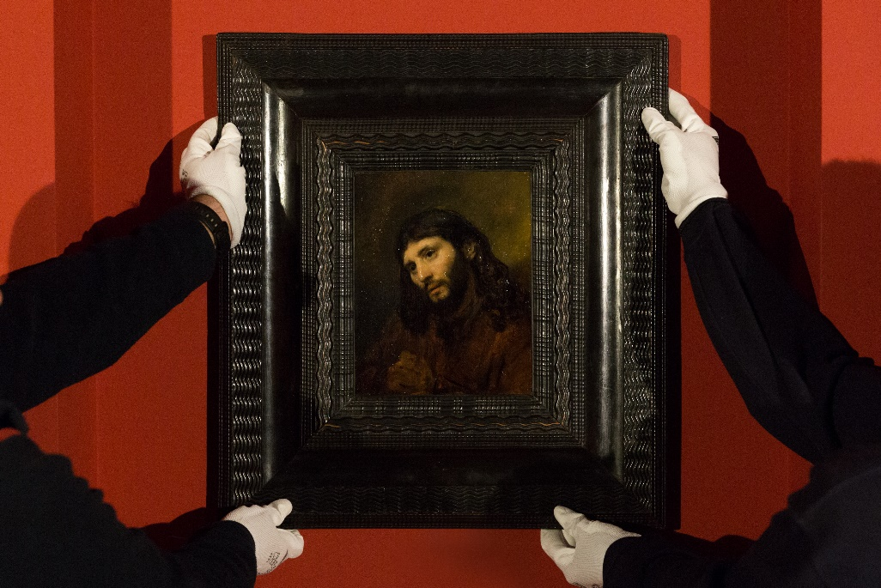

Staff at Louvre Abu Dhabi install the museum’s new acquisition, Rembrandt’s Head of a Young Man, ahead of their new exhibition opening on Thursday 14 February © Louvre Abu Dhabi / Photo by Seeing Things – Ismail Noor

(Abu Dhabi, 10 February 2019) Louvre Abu Dhabi has acquired a rare oil sketch—Head of a young man, with clasped hands: Study of the figure of Christ, ca. 1648–56—by Rembrandt van Rijn (1606–1669), one of the most celebrated artists of the Dutch Golden Age. Painted on oak panel in the Dutch Republic (now the Netherlands) and identified as the Master’s work in the 1930s, it belongs to a series of oil sketches referred to as Rembrandt’s Face of Jesus group. Head of a young man was purchased by Louvre Abu Dhabi in December.

This masterpiece is the first work by Rembrandt known to have been acquired for a public collection in the Gulf region. It appeared recently in exhibitions at the Musée du Louvre, Paris; Philadelphia Museum of Art; Detroit Institute of Art; and Rembrandt House Museum in Amsterdam. It will make its first appearance at Louvre Abu Dhabi in the exhibition Rembrandt, Vermeer & the Dutch Golden Age: Masterpieces from The Leiden Collection and the Musée du Louvre before joining Louvre Abu Dhabi’s permanent collection.

The acquisition of this rare masterpiece follows the unveiling of 11 new additions to Louvre Abu Dhabi’s permanent collection in October 2018. In keeping with the museum’s mission to highlight cross-cultural connections in a variety of forms, last year’s acquisitions include a range of exquisite objects from around the world and the region, including a monumental Buddhist sculpture from China (11th-12th CE), four tapestries from French royal manufacturers depicting The Hunts of Maximilian, the Duke of Brabant, as well as a rare Ottoman horse armour (15th-16th CE).

Manuel Rabaté, Director, Louvre Abu Dhabi, said: “Rembrandt was one of history of art’s greatest storytellers, with an exceptional ability to capture the human soul in his artworks. With this latest acquisition, the first ever Rembrandt joining a museum collection in the Gulf, our visitors can experience the power of his creations first-hand, initially in our opening exhibition for 2019 and following that in our galleries. It will join the 650 artworks of the museum’s collection from cultures around the world, celebrating the universal creativity of humanity”.

Dr. Souraya Noujaim, Scientific, Curatorial and Collections Management Director, Louvre Abu Dhabi, added: “We make each new addition to Louvre Abu Dhabi’s expanding collection with great rigor and care, in order to deepen and enhance the museum’s universal narrative. This exceptional work reflects the new cultural perspectives that emerged during the Dutch Golden Age due to international trade expansion and exchange of ideas. It also demonstrates the great Master's understanding of the fragility and intense spirituality of life, which inspired so many artists after him.”

The Dutch Golden Age was a brief period during the 17th century when the new Dutch merchant republic, freshly independent from the Spanish Crown, was regarded as the most prosperous state in Europe. Worldwide trade led by the Dutch East India Company, combined with military advancements and new developments in art and science, gave the Low Countries (the coastal region of northwestern Europe, consisting of Belgium, the Netherlands, and Luxembourg) an important advantage throughout Europe and the world. Major commissions brought Vermeer and Rembrandt to the forefront of a new artistic movement, in which Protestant workers developed new themes and iconographies depicting a more realistic daily life.

In Head of a young man, the face of the black-haired man seems to be both illuminated and rendered through large brushed gestures. The same model appears in a series of studies and works by Rembrandt that was created during the same period as the artist’s renowned Supper at Emmaus (Paris, Musée du Louvre, ca. 1648).

Head of a young man is one of the finest examples of Rembrandt’s seven surviving oil sketches from the Face of Jesus group. When viewed with the other surviving sketches, it reveals the way in which Rembrandt could find the best angle or profile to use light to portray Jesus “after life,” with the model probably coming from the local Jewish community.

The portrait and subject matter show a new representation in the Christian world. The clasped hands emphasise narrative not distinguishable at first glance. And Rembrandt chose to represent a man in prayer, rather than a king, expressing—in an ecumenical way—the humble humanity of man.

The exhibition Rembrandt, Vermeer & the Dutch Golden Age: Masterpieces from The Leiden Collection and the Musée du Louvre is co-curated by Blaise Ducos, Chief Curator of Dutch and Flemish paintings at the Musée du Louvre and Lara Yeager-Crasselt, Curator of The Leiden Collection and a specialist in 17th century Dutch and Flemish art. The exhibition will be on view from February 14 through May 18, 2019, at Louvre Abu Dhabi. Entrance to the exhibition is free with general admission and children under 13 years of age are free. For more information on the exhibition or ticket bookings, please visit or call Louvre Abu Dhabi at +971 600 56 55 66.

-End-

Notes to editors:

Artwork details

Artist Rembrandt van Rijn
Title Head of a young man, with clasped hands: Study of the Figure of Christ, ca. 1648-56
Date ca. 1648–56
Type Oil and oak panel
Dimensions 25.5 x 20.1 cm
Photo credit © Louvre Abu Dhabi / Photo by Seeing Things – Ismail Noor

Follow Louvre Abu Dhabi on social media: Facebook (Louvre Abu Dhabi), Twitter (@LouvreAbuDhabi) and Instagram (@LouvreAbuDhabi) #LouvreAbuDhabi

Visitor Information

Louvre Abu Dhabi hours are: Saturday, Sunday, Tuesday, and Wednesday, 10 am–8 pm; Thursday and Friday, 10 am–10 pm. The museum is closed on Mondays.

Last entries and ticket purchases end 30 minutes prior to closing. Special visitor hours will be in effect during some holidays and Ramadan.

General admission tickets are 60 AED (excluding 5% VAT). Tickets are 30 AED (excluding 5% VAT) for visitors ages 13-22, UAE education professionals, and members of the military.

Admission is free for members of the museum’s loyalty programme, children under the age of 13, ICOM or ICOMOS members, journalists and visitors with special needs and their companions.

ABOUT LOUVRE ABU DHABI
Created by an exceptional agreement between the governments of Abu Dhabi and France, Louvre Abu Dhabi was designed by Jean Nouvel and opened on Saadiyat Island in November 2017. The museum is inspired by traditional Islamic architecture and its monumental dome creates a rain of light effect and a unique social space that brings people together.
Louvre Abu Dhabi celebrates the universal creativity of mankind and invites audiences to see humanity in a new light. Through its innovative curatorial approach, the museum focuses on building understanding across cultures: through stories of human creativity that transcend civilisations, geographies and times.
The museum’s growing collection is unparalleled in the region and spans thousands of years of human history, including prehistoric tools, artefacts, religious texts, iconic paintings and contemporary artworks. The permanent collection is supplemented by rotating loans from 13 French partner institutions, regional and international museums.
Louvre Abu Dhabi is a testing ground for new ideas in a globalised world and champions new generations of cultural leaders. Its international exhibitions, programming and Children’s Museum are inclusive platforms that connect communities and offer enjoyment for all.
In 2019—the declared Year of Tolerance in the United Arab Emirates—Louvre Abu Dhabi will continue to be a hub for all cultures and a symbol of openness, hope, tolerance and inclusivity in the Arab world.

ABOUT MUSÉE DU LOUVRE
The Louvre in Paris opened in 1793, during the French Revolution, and from the very beginning was intended to provide inspiration for contemporary art. Courbet, Picasso, Dalí and so many others came to its hallowed halls to admire the old masters, copy them, immerse themselves in masterpieces and improve and fuel their own art. As an ancient royal residence, the Louvre is inextricably linked to eight centuries of French history. As a universal museum, its collections, among the best in the world, span many millennia and miles, from the Americas to Asia. Over 38,000 artworks are grouped into eight curatorial departments, including universally-admired works such as the Mona Lisa, the Winged Victory of Samothrace and the Venus de Milo. With 10.2 million guests in 2018, the Louvre is the most visited museum in the world.

ABOUT THE LEIDEN COLLECTION
The Leiden Collection, founded in 2003 by American collectors Dr. Thomas S. Kaplan and his wife, Daphne Recanati Kaplan, comprises some 250 paintings and drawings and represents one of the largest and most important assemblages of 17th-century Dutch paintings in private hands.
The Collection is named after Rembrandt’s native city in honor of the master’s greatness and focuses on the works of Rembrandt and his followers, illuminating the personalities and themes that shaped the Golden Age over five generations. The Collection is the most comprehensive representation of the Leiden artists known as fijnschilders (“fine manner painters”), who concentrated on painting portraits, tronies (character studies), genre scenes, and history paintings.

ABOUT AGENCE FRANCE-MUSÉUMS
Created in 2007 following the intergovernmental agreement between Abu Dhabi and France, Agence France-Muséums has been for 10 years a key link between France and the UAE in the accomplishment of the Louvre Abu Dhabi.
By gathering for the first time the collections and the expertise of the French cultural institutions involved, AFM has provided since its creation assistance and expertise to the authorities of the United Arab Emirates in the following areas: definition of the scientific and cultural programme, assistance in project management for architecture including museography, signage and multimedia projects, coordination of the loans from French collections and organization of temporary exhibitions, guidance with the creation of a permanent collection, and support with the museum’s policy on visitors.
AFM now continues its missions for Louvre Abu Dhabi after its opening with the training of the museum’s professionals, the coordination of loans from French museums for 10 years and the organisation of temporary exhibitions for 15 years.
Agence France-Muséums brings together the Louvre Abu Dhabi partner institutions: Musée du Louvre, Centre Pompidou, Musées d’Orsay et de l’Orangerie, Bibliothèque nationale de France, Musée du quai Branly-Jacques Chirac, Réunion des Musées Nationaux et du Grand Palais (RMN-GP), Château de Versailles, Musée national des arts asiatiques-Guimet, Musée de Cluny – musée national du Moyen-Âge, École du Louvre, Musée Rodin, Domaine National de Chambord, Musée des Arts Décoratifs (MAD), Cité de la Céramique – Sèvres & Limoges, Musée d’Archéologie nationale – Saint-Germain en Laye, Château de Fontainebleau, and OPPIC (Opérateur du patrimoine et des projets immobiliers de la culture).

ABOUT SAADIYAT CULTURAL DISTRICT
Saadiyat Cultural District on Saadiyat Island, Abu Dhabi, is devoted to culture and the arts. An ambitious cultural undertaking for the 21st century, it will be a nucleus for global culture, attracting local, regional and international guests with unique exhibitions, permanent collections, productions and performances. Its groundbreaking buildings will form a historical statement of the finest 21st century architecture; Zayed National Museum, Louvre Abu Dhabi and Guggenheim Abu Dhabi. These museums will complement and collaborate with local and regional arts and cultural institutions including universities and research centres.

ABOUT THE DEPARTMENT OF CULTURE AND TOURISM – ABU DHABI
The Department of Culture and Tourism – Abu Dhabi conserves and promotes the heritage and culture of Abu Dhabi emirate and leverages them in the development of a world-class, sustainable destination of distinction that enriches the lives of visitors and residents alike. The Department manages the emirate’s tourism sector and markets the destination internationally through a wide range of activities aimed at attracting visitors and investment. Its policies, plans and programmes relate to the preservation of heritage and culture, including protecting archaeological and historical sites and to developing museums, including the Louvre Abu Dhabi, the Zayed National Museum and the Guggenheim Abu Dhabi. The Department of Culture and Tourism supports intellectual and artistic activities and cultural events to nurture a rich cultural environment and honour the emirate’s heritage. A key role played by the Department is to create synergy in the destination’s development through close co-ordination with its wide-ranging stakeholder base.

