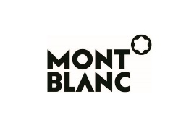
Official Sponsor

Press Release

Louvre Abu Dhabi opens exhibition in partnership with Centre Pompidou, connecting the languages of image and text through abstraction and calligraphy

Abstraction and Calligraphy – Towards a Universal Language
is on view from
17 February – 12 June 2021

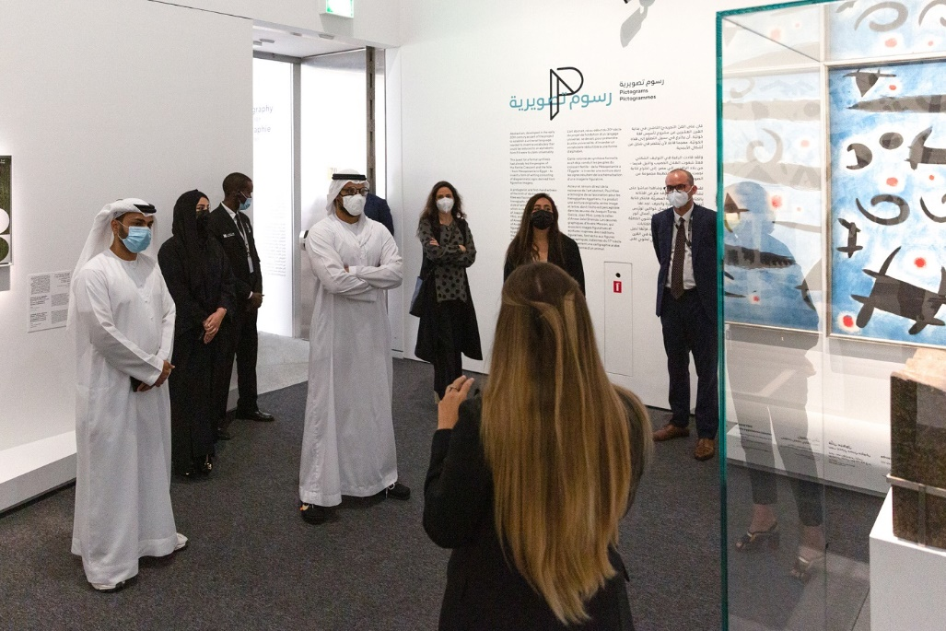
HE Mohamed Khalifa Al Mubarak, Chairman, Department of Culture and Tourism – Abu Dhabi, HE Saood Al Hosani, Undersecretary, Department of Culture and Tourism – Abu Dhabi, Manuel Rabaté, Director, Louvre Abu Dhabi, Dr. Souraya Noujaim, Scientific, Curatorial & Collections Management Director, Louvre Abu Dhabi, Marwa Al Menhali - Business Support Director, Rita Aoun-Abdo, Executive Director, Culture, Department of Culture and Tourism – Abu Dhabi, Maisa Al Qassimi - Senior Project Manager Guggenheim Abu Dhabi
Abu Dhabi, 16 February 2021: Opening to the public on Wednesday, Louvre Abu Dhabi’s first international exhibition of 2021, Abstraction and Calligraphy – Towards a Universal Language (17 February – 12 June 2021), invites visitors to explore the dawn of modern abstraction through sign and symbol, tracing origins to Asian and Arabic calligraphy and charting sites of mutual inspiration around the world. Curated by Didier Ottinger, assisted by Marie Sarré, the exhibition marks a second major collaboration between the Centre Pompidou and Louvre Abu Dhabi. This international exhibition is sponsored by Montblanc, a Maison whose innovative craftsmanship continues to influence the culture of writing.

Bringing together more than 80 masterworks on loan from 16 partner institutions, with six works from Louvre Abu Dhabi’s own permanent collection, the exhibition will showcase how 20th century abstract artists including Paul Klee, André Masson, Wassily Kandinsky, Cy Twombly, Lee Krasner, and Jackson Pollock felt the need to establish a new universal, visual language that was inspired by calligraphy. The show will also focus on 20th and 21st century Arab artists – from Dia Azzawi and Anwar Jalal Shemza, to Ghada Amer, Shirazeh Houshiary, Mona Hatoum and others – for whom the letterform was a continuous source of inspiration, freeing writing from its purely linguistic function and investing it with new artistic value. The exhibition will also feature installations from two contemporary artists, eL Seed and Sanki King, demonstrating how artists today are still seeking new visual forms to respond to current societal changes.

Sincere thanks goes to each of the lending institutions for this exhibition: Centre National d’Art et de Culture Georges Pompidou, Musée du Louvre, The Guggenheim Abu Dhabi, Musée de Grenoble, Centre National des Arts Plastiques, The Adolph and Esther Gottlieb Foundation, The Pollock-Krasner Foundation, Inc., Administration Jean Matisse, eL Seed Studio, Musée Municipal de Saint Germain Laval, Galerie Michael Werner, Märkisch Wilmersdorf, Galerie Jeanne Bucher Jaeger, Galerie Jacques Bailly, The McKee Gallery, Mona Hatoum Studio, and noirmontartproduction.

HE Mohamed Khalifa Al Mubarak, Chairman of the Department of Culture and Tourism - Abu Dhabi, remarked: “I feel great pride and excitement in entering Louvre Abu Dhabi’s galleries for this first international exhibition of the year. Once again, the museum offers its audiences not only the highest quality of artworks but an innovative curatorial vision. The masterworks in Abstraction and Calligraphy, some on display in the region for the very first time, are exceptional for many reasons. Not only because they have been crafted by some of the world’s most celebrated artists, but because they tell stories of discovery and inspiration across time, cultures and geographies.

“Abu Dhabi is a fitting setting for such an exhibition, as the Emirate’s success proves that growth and prosperity come from cross-cultural collaboration, understanding, and openness. Art and culture inspire these in each of us, and Louvre Abu Dhabi continues to play a significant role in developing our city into a vibrant, creative global hub,” HE Al Mubarak continued. “This exhibition is a continuation of the important work DCT Abu Dhabi has been doing throughout the past year, where in spite of challenges faced due to the global pandemic, we have delivered innovative and ambitious new cultural initiatives alongside diverse, dynamic cultural programming targeting all segments of the Abu Dhabi community. The adaptability and agility we have demonstrated during this time has enabled the emirate’s cultural offering to constantly evolve to meet the needs of our audiences.”

Manuel Rabaté, Director of Louvre Abu Dhabi, said: “We are emerging from the very difficult past year of 2020, and it is a pleasure to invite the great curator Didier Ottinger to explore the relationship between abstraction and calligraphy, two visual languages, intimately entwined. Louvre Abu Dhabi will offer audiences an exploration of a universal language through pictograms, signs, symbols, lines, and other traces of the hands of the artists. This second major collaboration with Centre Pompidou brings their abstract masterworks – of Cy Twombly, Lee Ufan, Wassily Kandinsky, Henri Michaux, Juan Miró, Christian Dotremont, Jean Dubuffet, André Masson, and Nasser Al Salem – here to Abu Dhabi for the first time. This exhibition speaks to the strength of our partner network of museums, and the mutual trust we share in the interest of offering access and moments of discovery to our audiences. We are ready and waiting to welcome visitors back safely, offering this rare opportunity to see so many abstract masterpieces displayed side-by-side with the numerous global influences that shaped this visual language.”

Curator of the exhibition, Didier Ottinger, Deputy Director, Cultural Programming, MNAM-CC, commented, “Exchanges and dialogue characterise the project I developed for Louvre Abu Dhabi—dialogues between spaces and times that are embraced by the Universal Museum; dialogue between images and letters, illustrated by the mutual fascination between calligraphy and image makers, and vice-versa; dialogue in the space between the artists of East and West, dialogues that bring together an ancient Egyptian stele and the ‘pictograms’ of a New York street artist—the shared dream of a universal language.”

Dr. Souraya Noujaim, Scientific, Curatorial and Collections Management Director at Louvre Abu Dhabi, added, “This exhibition opens the third cultural season of Louvre Abu Dhabi, which is devoted to ‘East–West’ exchanges and explores the remarkable avenues and voices that have characterised the creativity of both. The sources of abstraction that might be said to have dominated 20th-century art are found in the attention that many artists paid to the varied signs, calligraphies and ideograms of non-Western cultures. Beyond the limits of immediate sensory experience, in an environment where letters are present everywhere in declamation, calligraphy and graffiti, Asia and North Africa were intuitively experienced as an essential model. This almost mystical dimension of gesture and letter finds an echo in the Arab Hurufiyya movement, whose importance in the development of contemporary abstraction should not be underestimated. The exhibition, therefore, aims to bring together works from East and West, and to show what Western art has learned from different forms of calligraphy belonging to cultures and systems of writing and thought very foreign to it.”

The exhibition is organised in four sections, with the first focussing on pictograms, symbolic figurative images that represented ideas in ancient civilisations such as Mesopotamia and Egypt, and the way they inspired abstract artists. The second chapter explores signs, that in the history of writing, took over from pictograms, breaking writing’s attachment to imagery. The third section will be devoted to lineaments, revealing how Western artists incorporated the energy of Eastern calligraphy in their brushstrokes to produce free and fluid lines. Concluding the exhibition, calligraphy focuses on the ways artists and poets around the world – from Brion Gysin and Henri Michaux to Shakir Hassan Al Said and Sliman Mansour – incorporated calligraphic signs in their practice.

To facilitate onsite engagement with the exhibition, Louvre Abu Dhabi’s Education team has developed a digital learning resource, which guides young visitors and their families through the exhibition space and its artworks. An animated character named Qalam will help visitors explore the designated trail and engage young visitors with selected artworks and artists. These interactions aim to inspire creative expression and help children learn about the history of pictograms, alphabets, and abstraction. Small groups can book a 45-minute Express Tour to explore the exhibition with a Museum Educator.

A detailed catalogue accompanies the exhibition, available in English, Arabic, and French. It serves as an in-depth exploration of the themes, movements, and moments in the show. The catalogue includes a preface by Dr. Souraya Noujaim with essays by the late Béatrice André-Salvini (to whom the publication is dedicated), Didier Ottinger, and Alice Querin on topics from the earliest forms of writing to the dialogue between East and West through pictograms and calligraphy, and the Hurufiyya movement. The catalogue will be available in the Museum Boutique and online Boutique.

Cultural Programme

Abstraction and Calligraphy – Towards a Universal Language will also be accompanied by an extensive cultural programme, available entirely online, celebrating the many mediums and artistic practices utilising this universal language.

Following the exhibition opening and available for viewing on Louvre Abu Dhabi’s website, the curator of the exhibition, Didier Ottinger of Centre Pompidou, will give a talk on how calligraphy travelled across borders, the evolution of symbols to the formation of language, the music and sounds behind drawn lines, the meditative and spiritual practice behind the word, and an exploration of calligraphy and abstraction from cave painting to street art.

The programme will continue with a calligraphy demonstration and talk, also to be made available on Louvre Abu Dhabi’s website, from Saturday, 6 March at 5pm. Emirati artist and calligrapher Mohamed Mandi will take the audience through a live calligraphy demonstration and speak about his practice, tracing the history of the meaning of calligraphy, the meditative act of a brush stroke and the spiritual significance of the letter.

A pop-up performance featuring musicians from Berklee Abu Dhabi will go live on Louvre Abu Dhabi’s YouTube channel on Wednesday, 24 March from 8pm. Taking place under the museum’s famed dome, the performance will be a celebration of the mutual influence of contemporary artists and avant-garde composers of 20th century.

Three short film screenings will be shown on a loop at Louvre Abu Dhabi’s auditorium from 31 March – 2 April. The award-winning films Virtuos Virtuell by German film director Thomas Stellmach and artist Maja Oschmann and Wonder by Japanese animator Mirai Mizue will allow visitors to experience the relationship between abstract form and music. The screening of About a Mother by director Dina Velikovskaya will be dedicated to pictograms and symbols, with audiences discovering that the power of art that can transcend language and culture through the sacrifice of a mother for her children. A surprise screening will take place for three days starting 31 March from 5-9pm, where visitors to the museum and kayakers in the surrounding waters alike will have the opportunity to experience the walls of Louvre Abu Dhabi coming to life with a live film screening. The film programme is curated by Rinku Awatani.

-END-

Notes to editors:

Louvre Abu Dhabi is open Tuesday – Sunday from 10 am – 6:30 pm; closed on Mondays. Pre-purchased tickets are required to visit the museum. E-tickets can be reserved via the museum’s website.

Follow Louvre Abu Dhabi on social media: Facebook (Louvre Abu Dhabi), Twitter (@LouvreAbuDhabi) and Instagram (@LouvreAbuDhabi) #LouvreAbuDhabi.

For more information on Louvre Abu Dhabi’s acquisitions policies and principles, visit our website.

Louvre Abu Dhabi has been certified as a “Go-Safe” site. Our partnership with VPS Healthcare means that the health and wellbeing of our visitors will be prioritized throughout their visit. From timed ticketing, to temperature checks, to the ample space to social distance throughout the galleries and outdoor spaces of the museum.

Ongoing offers and promotions:
Teachers are eligible for unlimited access to Louvre Abu Dhabi and its programming with the museum’s Teacher Pass. The Teacher Pass is available at AED 120 for teachers, academics and other educators holding valid accreditation, based in the UAE or abroad.
Further information and terms and conditions on all offers and promotions can be found on the museum’s website: www.louvreabudhabi.ae.

ABOUT LOUVRE ABU DHABI
Created by an exceptional agreement between the governments of Abu Dhabi and France, Louvre Abu Dhabi was designed by Jean Nouvel and opened on Saadiyat Island in November 2017. The museum is inspired by traditional Islamic architecture and its monumental dome creates a rain of light effect and a unique social space that brings people together.

Louvre Abu Dhabi celebrates the universal creativity of mankind and invites audiences to see humanity in a new light. Through its innovative curatorial approach, the museum focuses on building understanding across cultures: through stories of human creativity that transcend civilisations, geographies and times.

The museum’s growing collection is unparalleled in the region and spans thousands of years of human history, including prehistoric tools, artefacts, religious texts, iconic paintings and contemporary artworks. The permanent collection is supplemented by rotating loans from 13 French partner institutions, regional and international museums.

Louvre Abu Dhabi is a testing ground for new ideas in a globalised world and champions new generations of cultural leaders. Its international exhibitions, programming and Children’s Museum are inclusive platforms that connect communities and offer enjoyment for all.

ABOUT MUSÉE DU LOUVRE
The Louvre in Paris opened in 1793, during the French Revolution, and from the very beginning was intended to provide inspiration for contemporary art. Courbet, Picasso, Dalí and so many others came to its hallowed halls to admire the old masters, copy them, immerse themselves in masterpieces and improve and fuel their own art. As an ancient royal residence, the Louvre is inextricably linked to eight centuries of French history. As a universal museum, its collections, among the best in the world, span many millennia and miles, from the Americas to Asia. Over 38,000 artworks are grouped into eight curatorial departments, including universally admired works such as the Mona Lisa, the Winged Victory of Samothrace and the Venus de Milo. With 9.6 million guests in 2019, the Louvre is the most visited museum in the world.

ABOUT CENTRE POMPIDOU
The Centre Pompidou, the French national cultural institution established in Paris in 1977, incorporates the Musée National d’Art Moderne, which houses the richest collection of modern and contemporary art in Europe, and one of the two largest in the world. From magnificent historical archives to the newest acquisitions, the collection encompasses the realms of visual arts, photography, new media, graphic arts, experimental cinema, architecture and design. It contains more than 120,000 works and is a genuine reference in 20th and 21st century art. The Centre Pompidou is a melting pot of art and culture, where visual arts, live performance, cinema music and ideological debate come together. Deeply rooted in the city and wide open to the world and to innovation, the Centre Pompidou examines major societal issues and the ever-changing nature of the modern world through the lens of creativity.

The symbolic building, designed by architects Renzo Piano and Richard Rogers, accommodates a hugely diverse programme covering all disciplines and appealing to all audiences. More than 3.5 million visitors pour through its doors every year to take in the museum collections, temporary exhibitions,

The Centre Pompidou offers a unique form of cultural outreach, true to its spirit of openness and its desire to make culture and design accessible to the broadest possible audience. It also puts on various regional events, in the form of exhibitions, loans or long-term partnerships with local authorities. As part of the network of leading international museums, the Centre Pompidou develops and presents major exhibitions designed to showcase France and illustrate its influence.

Renowned around the world for its expertise and know-how, this unique institution, long established in Paris and latterly in Metz, is now also present in Malaga and Brussels and Shanghai.”

ABOUT FRANCE MUSÉUMS
Following the intergovernmental agreement between France and the Emirates of Abu Dhabi signed in 2007, France Muséums, a cultural consulting and engineering agency, was created to work towards the creation of Louvre Abu Dhabi and support the project in all its dimensions (strategic, scientific, cultural, building, human resources).

Since the opening of the UAE museum in 2017, France Muséums continues to support Louvre Abu Dhabi in four main fields of activity: the management and coordination of loans from French museums for the permanent galleries of the museum, the organisation and production of 4 international exhibitions per year, training of teams and a wide range of consultancy and auditing assignments in all areas of museum management.

France Muséums mobilise its teams based in Paris and Abu Dhabi and a network of 17 major French cultural institutions and museum partners : Musée du Louvre, Centre Pompidou, Musées d’Orsay et de l’Orangerie, Bibliothèque nationale de France, Musée du quai Branly-Jacques Chirac, Réunion des Musées Nationaux et du Grand Palais (RMN-GP), Château de Versailles, Musée national des arts asiatiques-Guimet, Musée de Cluny – musée national du Moyen-Âge, École du Louvre, Musée Rodin, Domaine National de Chambord, Musée des Arts Décoratifs (MAD), Cité de la Céramique – Sèvres & Limoges, Musée d’Archéologie nationale – Saint-Germain en Laye, Château de Fontainebleau, and OPPIC (Opérateur du patrimoine et des projets immobiliers de la culture).
ABOUT THE DEPARTMENT OF CULTURE AND TOURISM – ABU DHABI
The Department of Culture and Tourism – Abu Dhabi (DCT Abu Dhabi) drives the sustainable growth of Abu Dhabi’s culture and tourism sectors, fuels economic progress and helps achieve Abu Dhabi’s wider global ambitions. By working in partnership with the organisations that define the Emirate’s position as a leading international destination, DCT Abu Dhabi strives to unite the ecosystem around a shared vision of the Emirate’s potential, coordinate effort and investment, deliver innovative solutions, and use the best tools, policies and systems to support the culture and tourism industries.

DCT Abu Dhabi’s vision is defined by the Emirate’s people, heritage and landscape. We work to enhance Abu Dhabi’s status as a place of authenticity, innovation, and unparalleled experiences, represented by its living traditions of hospitality, pioneering initiatives and creative thought.

ABOUT GUGGENHEIM ABU DHABI
Guggenheim Abu Dhabi will promote the understanding and appreciation of contemporary art, architecture, and other manifestations of modern and contemporary visual culture from an international perspective. A curatorial programme with a transcultural perspective on art and visual culture from the 1960s to the present will have a strong focus on art from West Asia, North Africa, and South Asia, exploring the specific identity derived from the cultural traditions of Abu Dhabi and the United Arab Emirates. The future museum, and its growing collection, is owned by the Government of Abu Dhabi. Surrounded almost entirely by water, Guggenheim Abu Dhabi will have spectacular views of the Saadiyat Cultural District and the Arabian Gulf. Galleries, many unprecedented in scale, are distributed around the central atrium on four levels connected by glass bridges above. Open to the elements, the museum cones housing contemporary art commissions, recall the region’s ancient wind-towers, which both ventilate and shade the exterior courtyards in a fitting blend of Arabian tradition and modern design. The museum will also feature a theatre, education workshops and classrooms, an onsite conservation lab, as well as a retail store, cafes, and a restaurant.

The museum will be a catalyst for scholarship in a variety of fields, chief among them the history of art from West Asia, North Africa, and South Asia in the 20th and 21st centuries. A dynamic programme of changing exhibitions will explore common themes and affinities among the work of artists across time and geography. An ambitious programme of commissions created for the collection and exceptional spaces of Guggenheim Abu Dhabi will reinforce the museum's commitment to working with artists and the art of our time.

Guggenheim Abu Dhabi is being developed in collaboration with the Solomon R. Guggenheim Foundation.

ABOUT MONTBLANC
Synonymous with excellence in craftsmanship and design, Montblanc has been pushing the boundaries of innovation ever since the Maison first revolutionized the culture of writing in 1906. Ingenuity and imagination continue to be driving forces for the Maison today as it advances its expression of fine craftsmanship across product categories: writing instruments, watches, leather goods, new technologies and accessories. Reflecting upon its ongoing mission to create fine lifetime companions born from bold ideas and expertly crafted through the skills of the Maison’s artisans, the iconic Montblanc Emblem has become the ultimate seal of performance, quality and an expression of sophisticated style. As part of its on-going commitment to elevating and support those who strive to leave their mark, Montblanc continues to assert its encouragement of education programs around the world and initiatives that inspire people to express their full potential.

Information for Press:
All Information and images are available to download on the Montblanc Press Lounge

Follow us on:

