Louvre Abu Dhabi Partners with VPS Healthcare to Provide Visitors and Staff with a Safe Experience
VPS Healthcare will help to enhance the museum’s health and safety measures, including COVID-19 testing and training webinars for staff
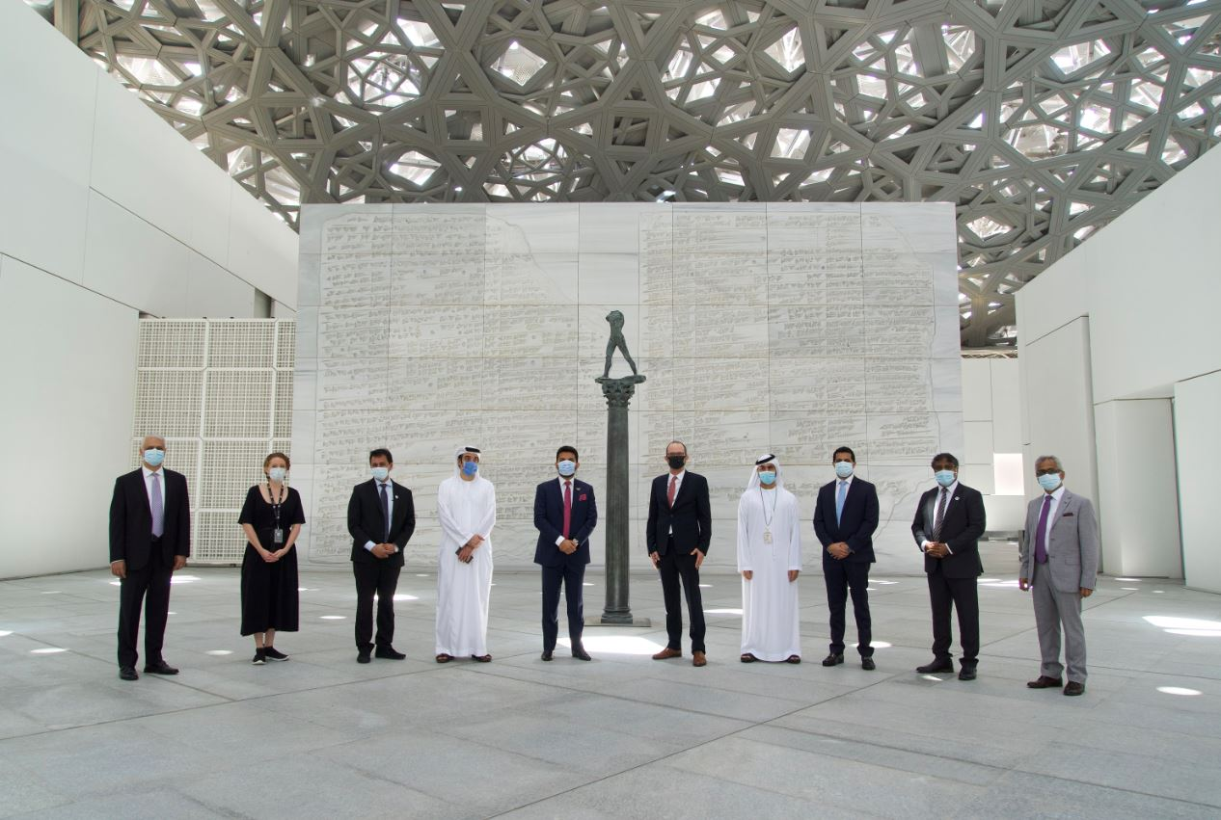
From left to right – Pankaj Paul – Director Strategy VPS Healthcare, Emma Cantwell – Director of Marketing and Communications at Louvre Abu Dhabi, John Sunil – CEO Burjeel Hospitals & Medical Center’s based in Abu Dhabi & Al Ain region, Omran Khouri – President Business Development VPS Healthcare, Dr. Shamsheer Vayalil, Chairman and Managing Director of VPS Healthcare, Manuel Rabaté, Director of Louvre Abu Dhabi, Hamad Al Hosani - Senior Government Relation Officer at Louvre Abu Dhabi, Safeer Ahmed – CEO Medeor| LLH| Lifecare Hospitals, Dr. Lalu Chacko -Medical Director - Burjeel Hospital, A.S. Pillai – Group Chief Financial Officer VPS Healthcare. © Department of Culture and Tourism – Abu Dhabi

Abu Dhabi, 14 July 2020: Louvre Abu Dhabi has announced a new partnership with VPS Healthcare, an integrated healthcare service provider headquartered in Abu Dhabi, to offer a comprehensive plan to provide COVID-19 precautionary measures and further ensure the safety of the museum’s staff and visitors.
Manuel Rabaté, Director of Louvre Abu Dhabi, said: “We are so pleased to engage in this innovative partnership with VPS Healthcare. For our reopening, Louvre Abu Dhabi is furthering its commitment to being a mindful museum. Offering the safest experience possible is a key element of this mission. As our healthcare partner, VPS will provide key resources and expertise that will allow us to maintain a safe and healthy environment for our staff and visitors. I am thrilled to see the art and medical communities come together through this unique collaboration. We look forward to working closely with VPS now and into the future as Abu Dhabi marks its steps towards recovery.”
Commenting on the partnership, Dr. Shamsheer Vayalil, Chairman and Managing Director of VPS Healthcare, said: “We are proud to partner with Louvre Abu Dhabi, which is one of the most prominent cultural sites and landmarks in Abu Dhabi. VPS Healthcare and Burjeel Hospital will be supporting in providing the safest environment for visitors and staff at the museum. The reopening of the museum signifies how effectively the UAE Government has tackled the spread of COVID-19 in the country. VPS Healthcare has been working in close association with government and health regulatory bodies from the beginning of the outbreak. We will be utilising the expertise and experience gained from working on the ground in providing the best experience for visitors at the museum.”
VPS Healthcare will offer several initiatives including continuous COVID-19 testing for the museum’s staff as part of the UAE Government’s National Screening Programme. Infection control webinars will also be arranged for staff, presented by professionals from VPS Healthcare.
Additionally, Louvre Abu Dhabi’s healthcare partner will provide the museum with nurses to oversee the thermal screening areas for visitors, while supporting risk mitigation of COVID-19 by conducting regular audits to ensure that the museum is adhering to the health and safety guidelines set forth by the Department of Culture and Tourism - Abu Dhabi (DCT Abu Dhabi).
Louvre Abu Dhabi is proud to receive the Go Safe certification issued by DCT Abu Dhabi, awarded to tourist destinations across the emirate that demonstrate the highest level of health and safety standards. The first programme of its kind in the region, the Go Safe certification requires destinations including hotels, attractions, malls and other public venues to undergo self-assessments according to the guidelines supplied by DCT Abu Dhabi.
-END-

Notes to editors:
Follow Louvre Abu Dhabi on social media: Facebook (Louvre Abu Dhabi), Twitter (@LouvreAbuDhabi) and Instagram (@LouvreAbuDhabi) #LouvreAbuDhabi
Visitor Information:
Health and Safety Measures
Measures include:
- Tickets are only available to purchase via Louvre Abu Dhabi’s website and must be booked for a specific arrival time slot. Once at the museum, visitors may visit for up to 3 hours.
- New opening hours: 10:00am – 6:30pm daily, closed on Monday. Last museum entry at 5:30pm
- A limited number of visitors per hour to allow for social distancing
- Thermal scanning of all visitors upon arrival
- Masks and gloves are required for all visitors throughout their stay at the museum
- Credit card or Smart payments only at all museum outlets, including food and beverage sites and the boutique
For the full list of the museum’s health and safety measures and more information on booking tickets visit: https://www.louvreabudhabi.ae/en/visit/plan-your-visit
ABOUT LOUVRE ABU DHABI
Created by an exceptional agreement between the governments of Abu Dhabi and France, Louvre Abu Dhabi was designed by Jean Nouvel and opened on Saadiyat Island in November 2017. The museum is inspired by traditional Islamic architecture and its monumental dome creates a rain of light effect and a unique social space that brings people together.
Louvre Abu Dhabi celebrates the universal creativity of mankind and invites audiences to see humanity in a new light. Through its innovative curatorial approach, the museum focuses on building understanding across cultures: through stories of human creativity that transcend civilisations, geographies and times.
The museum’s growing collection is unparalleled in the region and spans thousands of years of human history, including prehistoric tools, artefacts, religious texts, iconic paintings and contemporary artworks. The permanent collection is supplemented by rotating loans from 13 French partner institutions, regional and international museums.
Louvre Abu Dhabi is a testing ground for new ideas in a globalised world and champions new generations of cultural leaders. Its international exhibitions, programming and Children’s Museum are inclusive platforms that connect communities and offer enjoyment for all
ABOUT VPS HEALTHCARE
VPS Healthcare is an integrated healthcare service provider with 24 operational hospitals; over 125 health centres; 13,000 employees; medical support services spread across the GCC and India; one of the largest pharmaceutical manufacturing plants in Dubai; and retail pharmacies across Abu Dhabi. By providing comprehensive patient management at international quality standards across the MENA Region and beyond and to the entire strata of community, VPS Healthcare reflects a brand image of excellence in healthcare delivery system.

ABOUT MUSÉE DU LOUVRE
The Louvre in Paris opened in 1793, during the French Revolution, and from the very beginning was intended to provide inspiration for contemporary art. Courbet, Picasso, Dalí and so many others came to its hallowed halls to admire the old masters, copy them, immerse themselves in masterpieces and improve and fuel their own art. As an ancient royal residence, the Louvre is inextricably linked to eight centuries of French history. As a universal museum, its collections, among the best in the world, span many millennia and miles, from the Americas to Asia. Over 38,000 artworks are grouped into eight curatorial departments, including universally admired works such as the Mona Lisa, the Winged Victory of Samothrace and the Venus de Milo. With 9.6 million guests in 2019, the Louvre is the most visited museum in the world.

ABOUT SAADIYAT CULTURAL DISTRICT
Saadiyat Cultural District on Saadiyat Island, Abu Dhabi, is devoted to culture and the arts. An ambitious cultural undertaking for the 21st century, it will be a nucleus for global culture, attracting local, regional and international guests with unique exhibitions, permanent collections, productions and performances. Its ground-breaking buildings will form a historical statement of the finest 21st century architecture; Zayed National Museum, Louvre Abu Dhabi and Guggenheim Abu Dhabi. These museums will complement and collaborate with local and regional arts and cultural institutions including universities and research centres.

ABOUT THE DEPARTMENT OF CULTURE AND TOURISM – ABU DHABI
The Department of Culture and Tourism conserves and promotes the heritage and culture of Abu Dhabi emirate and leverages them in the development of a world-class, sustainable destination of distinction, which enriches the lives of visitors and residents alike. The organisation manages the emirate’s tourism sector and markets the destination internationally through a wide range of activities aimed at attracting visitors and investment. Its policies, plans and programmes relate to the preservation of heritage and culture, including protecting archaeological and historical sites and to developing museums, including Zayed National Museum, Guggenheim Abu Dhabi, and Louvre Abu Dhabi. The Department supports intellectual and artistic activities and cultural events to nurture a rich cultural environment and honour the emirate’s heritage. A key role is to create synergy in the destination’s development through close co-ordination with its wide-ranging stakeholder base.

