Press Release

Louvre Abu Dhabi Presents WE ARE NOT ALONE by Soundwalk Collective, a Science fiction Audio and Visual Experience Featuring 7 International Celebrities

- WE ARE NOT ALONE reinterprets Louvre Abu Dhabi’s iconic architecture through a futuristic story narrated by international talents including Hussain Al Jassmi, Willem Dafoe, Zhou Dongyu, Charlotte Gainsbourg, Nina Kraviz, Wim Wenders and Jean Nouvel

- WE ARE NOT ALONE is currently available on Louvre Abu Dhabi’s website
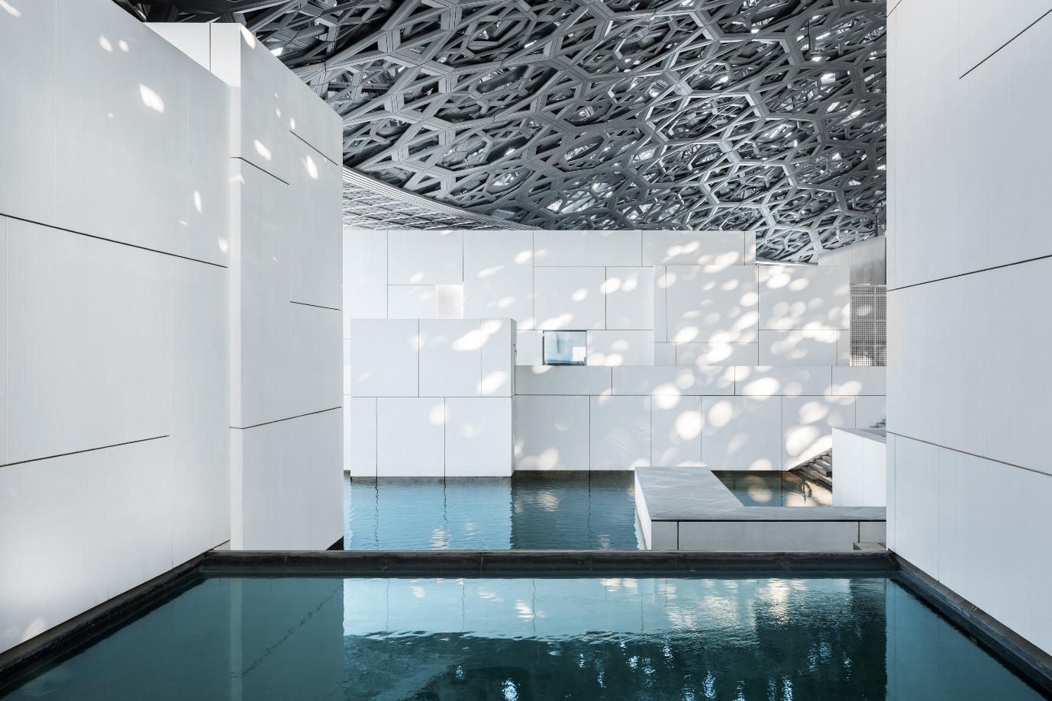
© Department of Culture and Tourism – Abu Dhabi. Photo: Mohamed Somji/Seeing Things

Abu Dhabi, 1 June 2020: Louvre Abu Dhabi added to its digital offering by releasing a 20-minute cinematic podcast entitled WE ARE NOT ALONE. Composed and produced by SOUNDWALK COLLECTIVE, an experimental group of artists and musicians, this podcast invites audiences to discover Louvre Abu Dhabi’s unique architecture through a science-fiction narrative. The podcast is accompanied by a short film that reimagines the museum as the backdrop to this poetic tale that takes place in a post-human galaxy thousands of years in the future.

WE ARE NOT ALONE by Soundwalk Collective is available on Louvre Abu Dhabi’s website in six languages. The story is narrated in the voices of renowned international talents including Emirati singer Hussain Al Jassmi in Arabic, American actor Willem Dafoe in English, French actress and singer Charlotte Gainsbourg in French and English, Chinese actress Zhou Dongyu in Mandarin, Russian is narrated by DJ, singer and producer Nina Kraviz, and German by filmmaker and playwright Wim Wenders.

The work utilises an original script written by Stéphan Crasneanscki. The story draws on the unique geometry, architecture and concepts behind Louvre Abu Dhabi’s creation. The experience begins with a message from Louvre Abu Dhabi’s architect Jean Nouvel, recorded for future generations. A narrator then places the audience within the tale’s futuristic world, inviting them to imagine the museum’s surroundings in a galaxy that has survived long after human extinction. Posing questions on free will, human nature and destiny, the experience reflects on the human condition in a dystopian future ruled by Artificial Intelligence.

HE Mohamed Khalifa Al Mubarak, Chairman of the Department of Culture and Tourism – Abu Dhabi commented: “In these unprecedented times, museums have a responsibility to encourage optimism and positivity in society. I am proud to see Louvre Abu Dhabi fulfilling this role and continuing to boost public morale with ever new and innovative campaigns. WE ARE NOT ALONE by Soundwalk Collective is a beautiful example of this. Mirroring the multiculturalism of its home city, Louvre Abu Dhabi has managed to bring the world to Abu Dhabi as seven high-profile talents from around the globe come together to help produce an exceptional experience. With this innovative science-fiction podcast, Louvre Abu Dhabi pushes the boundaries of creativity while complementing its many new digital initiatives.”

“Louvre Abu Dhabi tells the story of art history throughout the ages,” added Manuel Rabaté, Director of Louvre Abu Dhabi. “As we always look for new ways to experiment and innovate, we continue to explore new narratives inspired by our architecture and collection. WE ARE NOT ALONE is yet another example of our innovative approach to sharing stories of cultural connections,” he added.

Commenting on the commission, Stéphan Crasneanscki and Simone Merli from SOUNDWALK COLLECTIVE said: “WE ARE NOT ALONE allows audiences to ‘lose themselves’ as they imagine or walk under Louvre Abu Dhabi’s iconic dome and the dynamic dimensions that the museum offers. The experience creates a dialogue between past and present civilisations – as represented throughout Louvre Abu Dhabi’s collection – and creates an imaginative future where humanity has taken on a completely new form. The various narrators of this audio creation interact with each other through a script that transcends borders, languages, geographies and cultures.”

The podcast represents the first part of the collaboration with SOUNDWALK COLLECTIVE, offering a preview of an on-site 40-minute audio tour that will be available to visitors through Louvre Abu Dhabi’s multimedia guide at a later stage.

WE ARE NOT ALONE by Soundwalk Collective is part of Louvre Abu Dhabi’s extensive digital offering, providing free access to more content through virtual tours, video, audio and downloadable activities. These include opportunities to explore and discover the museum’s collection and exhibitions through the museum’s website and mobile app and “Art From Home” online resources; make and play, a series of online videos and colouring activities for families and children, and rich digital learning resources for teachers to engage with their students. As part of a partnership with anghami, the MENA region’s largest music streaming app, the museum has also launched a series of curated playlists to experience the museum’s collection in a different way. Inspired by the museum’s masterpieces, the hand-selected tracks feature a range of eclectic music genres.

Louvre Abu Dhabi is also participating in CulturAll, a new initiative launched by the Department of Culture and Tourism – Abu Dhabi to bring the emirate’s cultural landmarks online for audiences to enjoy their offerings from home. Follow @abudhabiculture and #CulturAll and stay tuned for experiences from the museum.

-END-

Notes to editors:
Follow Louvre Abu Dhabi on social media: Facebook (Louvre Abu Dhabi), Twitter (@LouvreAbuDhabi) and Instagram (@LouvreAbuDhabi) #LouvreAbuDhabi

ABOUT LOUVRE ABU DHABI
Created by an exceptional agreement between the governments of Abu Dhabi and France, Louvre Abu Dhabi was designed by Jean Nouvel and opened on Saadiyat Island in November 2017. The museum is inspired by traditional Islamic architecture and its monumental dome creates a rain of light effect and a unique social space that brings people together.

Louvre Abu Dhabi celebrates the universal creativity of mankind and invites audiences to see humanity in a new light. Through its innovative curatorial approach, the museum focuses on building understanding across cultures: through stories of human creativity that transcend civilisations, geographies and times.

The museum’s growing collection is unparalleled in the region and spans thousands of years of human history, including prehistoric tools, artefacts, religious texts, iconic paintings and contemporary artworks. The permanent collection is supplemented by rotating loans from 13 French partner institutions, regional and international museums.

Louvre Abu Dhabi is a testing ground for new ideas in a globalised world and champions new generations of cultural leaders. Its international exhibitions, programming and Children’s Museum are inclusive platforms that connect communities and offer enjoyment for all.

ABOUT SOUNDWALK COLLECTIVE
SOUNDWALK COLLECTIVE is an experimental sound collective founded by Stéphan Crasneanscki in New York City in 2000 and joined by Simone Merli in 2008. The Collective features a constellation of world-renowned sound artists and musicians. Their approach to composition combines anthropology, ethnography, non-linear narrative, psycho-geography, the observation of nature, and explorations in recording and synthesis. Distinguished collaborators include American singer, songwriter and poet Patti Smith, Ethiopian Jazz musician Mulatu Astatke, American photographer Nan Goldin and French-Swiss film director Jean-Luc Godard. The collective has also written original scores for contemporary dance choreographer Sasha Waltz.

ABOUT MUSÉE DU LOUVRE
The Louvre in Paris opened in 1793, during the French Revolution, and from the very beginning was intended to provide inspiration for contemporary art. Courbet, Picasso, Dalí and so many others came to its hallowed halls to admire the old masters, copy them, immerse themselves in masterpieces and improve and fuel their own art. As an ancient royal residence, the Louvre is inextricably linked to eight centuries of French history. As a universal museum, its collections, among the best in the world, span many millennia and miles, from the Americas to Asia. Over 38,000 artworks are grouped into eight curatorial departments, including universally admired works such as the Mona Lisa, the Winged Victory of Samothrace and the Venus de Milo. With 9.6 million guests in 2019, the Louvre is the most visited museum in the world.

ABOUT SAADIYAT CULTURAL DISTRICT
Saadiyat Cultural District on Saadiyat Island, Abu Dhabi, is devoted to culture and the arts. An ambitious cultural undertaking for the 21st century, it will be a nucleus for global culture, attracting local, regional and international guests with unique exhibitions, permanent collections, productions and performances. Its ground-breaking buildings will form a historical statement of the finest 21st century architecture; Zayed National Museum, Louvre Abu Dhabi and Guggenheim Abu Dhabi. These museums will complement and collaborate with local and regional arts and cultural institutions including universities and research centres.

ABOUT THE DEPARTMENT OF CULTURE AND TOURISM – ABU DHABI
The Department of Culture and Tourism conserves and promotes the heritage and culture of Abu Dhabi emirate and leverages them in the development of a world-class, sustainable destination of distinction, which enriches the lives of visitors and residents alike. The organisation manages the emirate’s tourism sector and markets the destination internationally through a wide range of activities aimed at attracting visitors and investment. Its policies, plans and programmes relate to the preservation of heritage and culture, including protecting archaeological and historical sites and to developing museums, including Zayed National Museum, Guggenheim Abu Dhabi, and Louvre Abu Dhabi. The Department supports intellectual and artistic activities and cultural events to nurture a rich cultural environment and honour the emirate’s heritage. A key role is to create synergy in the destination’s development through close co-ordination with its wide-ranging stakeholder base.

