Media Alert

Louvre Abu Dhabi reopens to the public on 24 June
Tickets are now available to book online

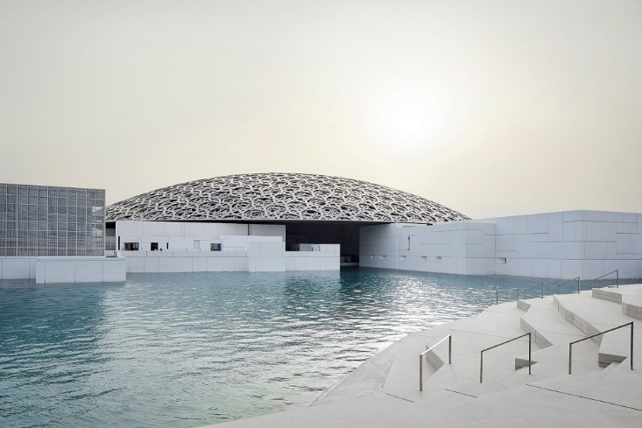

© Department of Culture and Tourism – Abu Dhabi. Photo: Hufton+Crow Architect: Jean Nouvel

Tickets can now be purchased on Louvre Abu Dhabi’s website ahead of the museum’s reopening on 24 June. Visitors will once again be able to experience Louvre Abu Dhabi’s world-class collection and view the latest international exhibition, Furusiyya: The Art of Chivalry between East and West, reopening on 1 July and extended to 18 October 2020.

Louvre Abu Dhabi is also pleased to now offer free admission tickets to visitors under the age of 18 as part of the museum’s mission to further engage younger audiences and families.

Manuel Rabaté, Director of Louvre Abu Dhabi, noted “We look forward to giving our museum back to the community and resuming our physical role as a space for sharing our many stories of cultural connections. As we prepare to reopen, we are furthering our commitment to being a mindful museum – a concept that has always been a part of our DNA and is now more urgent than ever before. This approach extends throughout our programming, collection, and the museum building itself as a meditative and contemplative space for the community to come together and find solace through culture, while feeling comfortable and safe. We have planned carefully and methodically alongside the Department of Culture and Tourism - Abu Dhabi to ensure that the appropriate health and safety measures are in place. I want to thank our dedicated staff for their resilience and hard work to prepare for this moment. We are eager and excited to welcome back visitors soon.”

Health and Safety Measures
Louvre Abu Dhabi is a mindful museum and the health and safety of our visitors and staff are of paramount importance to us. We are implementing comprehensive measures to ensure a safe and comfortable experience within the museum.

These measures include:
- New opening hours: 10:00am – 6:30pm daily, closed on Monday. Last museum entry at 5:30pm
- A limited number of visitors per hour to allow for social distancing
- Tickets are only available to purchase via Louvre Abu Dhabi’s website and must be booked for a specific arrival time slot. Once at the museum, visitors may visit for up to 3 hours.
- Thermal scanning of all visitors upon arrival
- Masks and gloves are required for all visitors throughout their stay at the museum
- Credit card or Smart payments only at all museum outlets, including food and beverage sites and the boutique
For the full list of the museum’s health and safety measures and more information on booking tickets visit: https://www.louvreabudhabi.ae/en/visit/plan-your-visit

Furusiyya: The Art of Chivalry between East and West Reopens from 1 July to 18 October
The exhibition explores the ancient roots of chivalry and how distinct practices of combat and knightly values led to a specific culture in the Islamic East and the largely Christian West. Pieces include Louvre Abu Dhabi’s spectacular Ottoman Horse Armour from the late 15th century, installed alongside a European Horse and Knight Armour from the first quarter of the 16th century, on loan from Musée de l'armée; a cameo from 260 A.D. depicting the Fight between Emperor Valerian and King Shapur from the collections of Bibliothèque Nationale de France; and the Turban Helmet of Sultan Bajazet II from Musée de l’armée, among other works.

Organised by Louvre Abu Dhabi, Musée de Cluny – Musée national du Moyen Âge and Agence-France Muséums. Curated by Elisabeth Taburet-Delahaye, Director, Musée de Cluny – Musée national du Moyen Âge; Carine Juvin, Curator, Department of Islamic Art, Musée du Louvre and Michel Huynh, Head Curator, Musée de Cluny – Musée national du Moyen Âge.

The exhibition is also available to experience through a 360 virtual tour on the museum’s website. Visitors can navigate throughout the entire exhibition and select 18 of the artworks on view for a closer look through clicking on a digital tag.

Digital Initiatives
Louvre Abu Dhabi will continue to connect with art lovers around the globe through its many digital programmes that offer free access to more content through virtual tours, video, audio, and downloadable activities.

Digital programmes include:
- Opportunities to explore and discover the museum’s collection and exhibitions through the website, mobile app and Art from Home resources
- Make and Play, a series of online videos and colouring activities for families and children
- Playlists curated by anghami – the leading music platform in the Middle East— inspired by the museum’s masterpieces
- Soundwalk Collective’s podcast, WE ARE NOT ALONE, an immersive science-fiction story that takes place within the museum and is narrated in six languages by international talents
-End-

Notes to editors:
Follow Louvre Abu Dhabi on social media: Facebook (Louvre Abu Dhabi), Twitter (@LouvreAbuDhabi) and Instagram (@LouvreAbuDhabi) #LouvreAbuDhabi

ABOUT LOUVRE ABU DHABI
Created by an exceptional agreement between the governments of Abu Dhabi and France, Louvre Abu Dhabi was designed by Jean Nouvel and opened on Saadiyat Island in November 2017. The museum is inspired by traditional Islamic architecture and its monumental dome creates a rain of light effect and a unique social space that brings people together.

Louvre Abu Dhabi celebrates the universal creativity of mankind and invites audiences to see humanity in a new light. Through its innovative curatorial approach, the museum focuses on building understanding across cultures: through stories of human creativity that transcend civilisations, geographies and times.

The museum’s growing collection is unparalleled in the region and spans thousands of years of human history, including prehistoric tools, artefacts, religious texts, iconic paintings and contemporary artworks. The permanent collection is supplemented by rotating loans from 13 French partner institutions, regional and international museums.

Louvre Abu Dhabi is a testing ground for new ideas in a globalised world and champions new generations of cultural leaders. Its international exhibitions, programming and Children’s Museum are inclusive platforms that connect communities and offer enjoyment for all.

ABOUT MUSÉE DU LOUVRE
The Louvre in Paris opened in 1793, during the French Revolution, and from the very beginning was intended to provide inspiration for contemporary art. Courbet, Picasso, Dalí and so many others came to its hallowed halls to admire the old masters, copy them, immerse themselves in masterpieces and improve and fuel their own art. As an ancient royal residence, the Louvre is inextricably linked to eight centuries of French history. As a universal museum, its collections, among the best in the world, span many millennia and miles, from the Americas to Asia. Over 38,000 artworks are grouped into eight curatorial departments, including universally admired works such as the Mona Lisa, the Winged Victory of Samothrace and the Venus de Milo. With 9.6 million guests in 2019, the Louvre is the most visited museum in the world. Open since 2012, the Islamic Art Department of the Louvre presents more than 3,000 objects, spanning 1,300 years of history and three continents, from Spain to Southeast Asia. Open since 2012, the Islamic Art Department of the Louvre presents more than 3,000 objects, spanning 1,300 years of history and three continents, from Spain to Southeast Asia.

