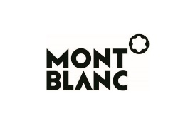
Official Sponsor

Press Release

Abstraction and Calligraphy – Towards a Universal Language:
Louvre Abu Dhabi’s first 2021 exhibition features abstract masterpieces
in dialogue, exploring a universal language of text and image

In collaboration with the Centre Pompidou

- February – 12 June 2021

- Louvre Abu Dhabi inaugurates its third season with Abstraction and Calligraphy – Towards a Universal Language, showcasing 101 artworks from 16 partner institution collections, including Guggenheim Abu Dhabi which is lending several works from its transnational collection of modern and contemporary art
- Works by Dia Azzawi, Mona Hatoum, Vassily Kandinsky, Paul Klee, Lee Krasner, André Masson, Jackson Pollock, Anwar Jalal Shemza, and Cy Twombly will be shown together, many for the first time in the region
- Includes two original artworks by contemporary artists eL Seed and Sanki King
- The show furthers Louvre Abu Dhabi’s curatorial strategy of connecting cultures by exploring two parallel timelines – of abstraction in the early 20th century, and of calligraphy, tracing back to ancient civilisations
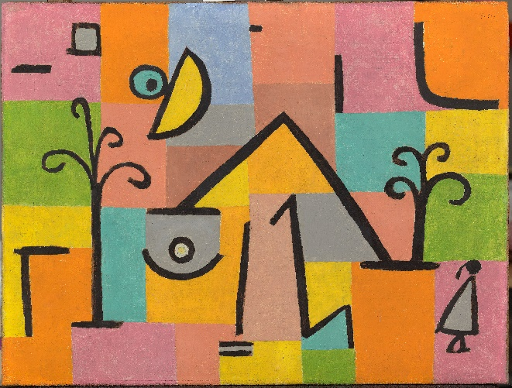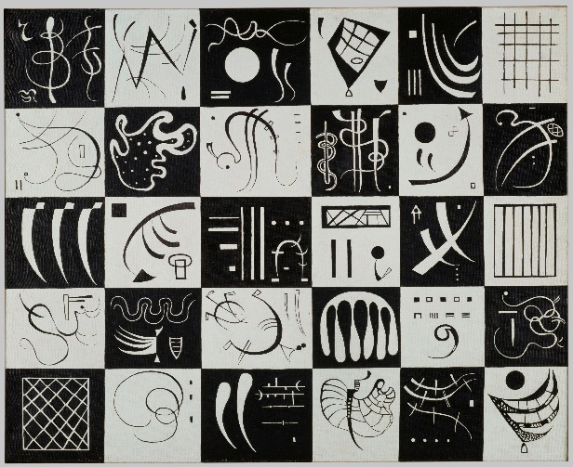

Left image: Paul Klee, Oriental Bliss (1938), oil on canvas, collection of Louvre Abu Dhabi, Photo credit ©Department of Culture and Tourism – Abu Dhabi/Photo: AFP | Right image: Vassily Kandinsky, Trente [Thirty] (1937), oil on canvas, collection of the Centre Pompidou, Paris, Musée national d’art moderne/Centre de création industrielle, Photo credit © Centre Pompidou, MNAM-CCI, Dist. RMN-Grand Palais / Philippe Migeat
Abu Dhabi, 3 February 2021: Louvre Abu Dhabi opens its third season with Abstraction and Calligraphy – Towards a Universal Language (17 February – 12 June 2021). In keeping with the third season’s theme of exchanges between East and West, this international exhibition marks the second major collaboration with the Centre Pompidou and is sponsored by Montblanc, a Maison whose innovative craftsmanship continues to influence the culture of writing. Charting sites of mutual inspiration around the world, and dedicated to artistic practices of abstraction, the show explores how 20th century artists established a new visual language by merging text and image, inspired by the earliest forms of mark-making and, particularly, calligraphy. The exhibition brings together 101 masterworks on loan from 16 partner institution collections, alongside seven works from Louvre Abu Dhabi’s permanent collection, and two monumental artworks by contemporary artists whose current-day practices bring recurring themes of the exhibition to life.

Organised in four themed sections, the exhibition will investigate the timeline of abstraction as a new visual language established by artists in the early 20th century. By highlighting the rich cultural exchange taking place at that time, visitors will discover how the abstract movements were inspired by a plethora of signs and symbols, philosophies, and artistic techniques from cultures and societies far from European and American capitals. Artists including Paul Klee, André Masson, Vassily Kandinsky, Cy Twombly, Lee Krasner, and Jackson Pollock sought a new universal language that enabled them to express their emotions in response to a rapidly changing society, breaking away from figurative conventions. The show will also focus on how these same influences informed the practices of artists from the region – from Dia Azzawi and Anwar Jalal Shemza, to Ghada Amer, Shirazeh Houshiary, and Mona Hatoum. The exhibition will be completed with installations from two contemporary artists, eL Seed and Sanki King, exploring how artists today are still seeking new visual forms to respond to current societal changes.

In collaboration with the Centre Pompidou and France Muséums, Abstraction and Calligraphy – Towards a Universal Language is curated by Didier Ottinger, Deputy Director, Cultural Programming, MNAM-CCI, assisted by Marie Sarré, Associate Curator, Modern Collections Department, MNAM-CCI. Works on loan will come from Centre Pompidou in Paris, Musée du Louvre in Paris, Centre National des Arts Plastiques, Paris, Administration Jean Matisse, Paris, Galerie Jacques Bailly in Paris, Galerie Jeanne Bucher Jaeger, Paris, Musée municipal de St Germain Laval, Musée des beaux-arts de Grenoble, The Pollock-Krasner Foundation in New York, The Adolph and Esther Gottlieb Foundation, New York, Galerie Michael Werner, Märkisch Wilmersdorf, Trebbin, The McKee Gallery, New York, Mona Hatoum Studio, London, noirmontartproduction, Paris and eL Seed Studio, Dubai. Also included will be works from Guggenheim Abu Dhabi.

“It is with pride and great excitement that we welcome the opening of the first Louvre Abu Dhabi international exhibition of 2021, especially as masterworks from so many illustrious lending partners will be on show here at Louvre Abu Dhabi, and in the region, for the very first time,” remarked HE Mohamed Khalifa Al Mubarak, Chairman of the Department of Culture and Tourism-Abu Dhabi. “Museums, with their ability to inspire curiosity, discovery and learning, are essential to every society, and we hold them in particular regard here in Abu Dhabi. It has become more apparent than ever the increasingly important role that art and culture play in our lives, providing wonder, intellectual stimulation and comfort, as well as a sense of connection to others in our communities and far beyond. What is also clear, and what was a primary message of the Reframing Museums symposium in November, is that trust and solidarity between countries and between arts institutions are what will ensure a vibrant future for a collaborative, international cultural sector.”

Manuel Rabaté, Director of Louvre Abu Dhabi, commented, “We are emerging from the very difficult past year of 2020, and it is a pleasure to invite the great curator Didier Ottinger to explore the relationship between abstraction and calligraphy, two visual languages, intimately entwined. Louvre Abu Dhabi will offer audiences an exploration of a universal language through pictograms, signs, symbols, lines, and other traces of the hands of the artists. This second major collaboration with Centre Pompidou brings their abstract masterworks – of Cy Twombly, Lee Ufan, Vassily Kandinsky, Henri Michaux, Juan Miró, Christian Dotremont, Jean Dubuffet, André Masson, Nasser Al Salem and Brice Marden – here to Abu Dhabi for the first time. This exhibition speaks to the strength of our partner network of museums, and the mutual trust we share in the interest of offering access and moments of discovery to our audiences. We are ready and waiting to welcome visitors back safely, offering this rare opportunity to see so many abstract masterpieces displayed side-by-side with the numerous global influences that shaped this visual language.”

Curator of the exhibition, Didier Ottinger, Deputy Director, Cultural Programming, MNAM-CC, commented, “Exchanges and dialogue characterise the project I developed for Louvre Abu Dhabi—dialogues between spaces and times that are embraced by the Universal Museum; dialogue between images and letters, illustrated by the mutual fascination between calligraphy and image makers, and vice-versa; dialogue in the space between the artists of East and West, dialogues that bring together an ancient Egyptian stele and the ‘pictograms’ of a New York street artist—the shared dream of a universal language.”

Dr. Souraya Noujaim, Scientific, Curatorial and Collections Management Director at Louvre Abu Dhabi, added, “This exhibition brings works by masters of abstraction together with sources of myriad influences. The calligraphic works are far from a unified codex of signs and symbols. They represent the diversity of cultures, languages—written and visual—and histories that span many continents and centuries. In the spirit of Louvre Abu Dhabi, this exhibition establishes a powerful dialogue between two distinct forms of expression – image and writing – revealing the common ground which unites them both. Appearing in unison, the visual and the verbal come together as one, singular form of expression, recalling what Ibn Khaldun terms ‘the two faces of thought.’ Many of the works and artists have never been shown in the region before. It is also the first time that Louvre Abu Dhabi will have works produced in conjunction with an exhibition.”
The first section of the show will focus on pictograms, symbolic figurative images that represented words and ideas in writing in ancient civilisations in Mesopotamia and Egypt. Work presented will include a painting by Swiss-German artist Paul Klee, who – inspired by his travels to Tunisia – created artwork that combined elements of images and letters stemming from his fascination with Egyptian hieroglyphics. His work influenced artists such as Joaquín Torres-García from Spain, Iraqi artist Dia Al-Azzawi and Pakistani artist Anwar Jalal Shemza. This section will also include works from American artist Adolph Gottlieb, inspired by images from Native American art, and French artist André Masson, who was inspired by 17th century Indian figurative inscriptions and Arabic calligraphy.

In line with the history of writing, the second section will focus on signs, which by their very form can express universal ideas. Works on show will include studies of signs by Russian artist Vassily Kandinsky, considered by many to be one of the inventors of abstract art. As an act of resistance to the Western world ravaged by war, many artists turned to Japan and China for inspiration. The signs traced in works by French-Hungarian painter Judit Reigl and German-French painter Hans Hartung echo symbols used by Chinese and Japanese calligraphers. The show will furthermore include works from French artists Georges Mathieu, who tried to develop a lyric and rapid gesture, and Julius Bissier, who was influenced by the Chinese philosophy of Taoism. Finally, Mona Hatoum’s works endeavour to create a new alphabet of signs through found objects.

The third section will be devoted to lineaments, revealing how Western artists appropriated the energy of Eastern calligraphy in their brushstrokes to produce free and fluid lines. In opposition to Western artistic inclination, the Surrealist movement invented a drawing technique called Automatism, using automatic movements to express the subconscious. It allowed them to artistically respond to a tumultuous interwar period between World War I and World War II. On display will be works by Surrealist André Masson as well as works by Jackson Pollock, Philip Guston, and Willem de Kooning, who were all influenced by Masson. Visitors will be able to see Jean Dubuffet’s primitive creations, inspired by a combination of graffiti, rock paintings and children’s drawings. Also on show will be Cy Twombly’s gestural drawings for curtains of the Opéra de Paris and Lee Krasner’s works, which take their inspiration from Kufic script from the Iraqi City of Kufa, the birthplace of Arabic calligraphy.

The exhibition will conclude with a section showing how both Western and Eastern artists incorporated calligraphy into their practice, such as Spanish artist Joan Miró, who referenced how closely painting and poetry are linked in the East. Following in his footsteps, the poets Brion Gysin, Henri Michaux and Christian Dotremont pursued the same path by painting poetry, inspired by their trips to North Africa, China and Lapland, respectively. Henri Matisse’s studies for his illustrated book Jazz, which he called “arabesques” in a tribute to Arabic writing, are also included here. Viewers will also discover how regional artists, including Shakir Hassan Al Said and Sliman Mansour, sought to free calligraphy from its purely linguistic function. This section will be completed by two original monumental artworks from contemporary artists—French-Tunisian artist eL Seed and Pakistani artist Sanki King.

-END-

Notes to editors:

Louvre Abu Dhabi is open Tuesday – Sunday from 10 am – 6:30 pm; closed on Mondays. Pre-purchased tickets are required to visit the museum. E-tickets can be reserved via the museum’s website.

Follow Louvre Abu Dhabi on social media: Facebook (Louvre Abu Dhabi), Twitter (@LouvreAbuDhabi) and Instagram (@LouvreAbuDhabi) #LouvreAbuDhabi.

For more information on Louvre Abu Dhabi’s acquisitions policies and principles, visit our website.

Louvre Abu Dhabi has been certified as a “Go-Safe” site. Our partnership with VPS Healthcare means that the health and wellbeing of our visitors will be prioritized throughout their visit. From timed ticketing, to temperature checks, to the ample space to social distance throughout the galleries and outdoor spaces of the museum.

Ongoing offers and promotions:
Teachers are eligible for unlimited access to Louvre Abu Dhabi and its programming with the museum’s Teacher Pass. The Teacher Pass is available at AED 120 for teachers, academics and other educators holding valid accreditation, based in the UAE or abroad.
Further information and terms and conditions on all offers and promotions can be found on the museum’s website: www.louvreabudhabi.ae.

ABOUT LOUVRE ABU DHABI
Created by an exceptional agreement between the governments of Abu Dhabi and France, Louvre Abu Dhabi was designed by Jean Nouvel and opened on Saadiyat Island in November 2017. The museum is inspired by traditional Islamic architecture and its monumental dome creates a rain of light effect and a unique social space that brings people together.

Louvre Abu Dhabi celebrates the universal creativity of mankind and invites audiences to see humanity in a new light. Through its innovative curatorial approach, the museum focuses on building understanding across cultures: through stories of human creativity that transcend civilisations, geographies and times.

The museum’s growing collection is unparalleled in the region and spans thousands of years of human history, including prehistoric tools, artefacts, religious texts, iconic paintings and contemporary artworks. The permanent collection is supplemented by rotating loans from 13 French partner institutions, regional and international museums.

Louvre Abu Dhabi is a testing ground for new ideas in a globalised world and champions new generations of cultural leaders. Its international exhibitions, programming and Children’s Museum are inclusive platforms that connect communities and offer enjoyment for all.

ABOUT MUSÉE DU LOUVRE
The Louvre in Paris opened in 1793, during the French Revolution, and from the very beginning was intended to provide inspiration for contemporary art. Courbet, Picasso, Dalí and so many others came to its hallowed halls to admire the old masters, copy them, immerse themselves in masterpieces and improve and fuel their own art. As an ancient royal residence, the Louvre is inextricably linked to eight centuries of French history. As a universal museum, its collections, among the best in the world, span many millennia and miles, from the Americas to Asia. Over 38,000 artworks are grouped into eight curatorial departments, including universally admired works such as the Mona Lisa, the Winged Victory of Samothrace and the Venus de Milo. With 9.6 million guests in 2019, the Louvre is the most visited museum in the world.

ABOUT CENTRE POMPIDOU
The Centre Pompidou, the French national cultural institution established in Paris in 1977, incorporates the Musée National d’Art Moderne, which houses the richest collection of modern and contemporary art in Europe, and one of the two largest in the world. From magnificent historical archives to the newest acquisitions, the collection encompasses the realms of visual arts, photography, new media, graphic arts, experimental cinema, architecture and design. It contains more than 120,000 works and is a genuine reference in 20th and 21st century art. The Centre Pompidou is a melting pot of art and culture, where visual arts, live performance, cinema music and ideological debate come together. Deeply rooted in the city and wide open to the world and to innovation, the Centre Pompidou examines major societal issues and the ever-changing nature of the modern world through the lens of creativity.

The symbolic building, designed by architects Renzo Piano and Richard Rogers, accommodates a hugely diverse programme covering all disciplines and appealing to all audiences. More than 3.5 million visitors pour through its doors every year to take in the museum collections, temporary exhibitions,

The Centre Pompidou offers a unique form of cultural outreach, true to its spirit of openness and its desire to make culture and design accessible to the broadest possible audience. It also puts on various regional events, in the form of exhibitions, loans or long-term partnerships with local authorities. As part of the network of leading international museums, the Centre Pompidou develops and presents major exhibitions designed to showcase France and illustrate its influence.
Renowned around the world for its expertise and know-how, this unique institution, long established in Paris and latterly in Metz, is now also present in Malaga and Brussels and Shanghai.”

ABOUT FRANCE MUSÉUMS
Following the intergovernmental agreement between France and the Emirates of Abu Dhabi signed in 2007, France Muséums, a cultural consulting and engineering agency, was created to work towards the creation of Louvre Abu Dhabi and support the project in all its dimensions (strategic, scientific, cultural, building, human resources).

Since the opening of the UAE museum in 2017, France Muséums continues to support Louvre Abu Dhabi in four main fields of activity: the management and coordination of loans from French museums for the permanent galleries of the museum, the organisation and production of 4 international exhibitions per year, training of teams and a wide range of consultancy and auditing assignments in all areas of museum management.

France Muséums mobilise its teams based in Paris and Abu Dhabi and a network of 17 major French cultural institutions and museum partners : Musée du Louvre, Centre Pompidou, Musées d’Orsay et de l’Orangerie, Bibliothèque nationale de France, Musée du quai Branly-Jacques Chirac, Réunion des Musées Nationaux et du Grand Palais (RMN-GP), Château de Versailles, Musée national des arts asiatiques-Guimet, Musée de Cluny – musée national du Moyen-Âge, École du Louvre, Musée Rodin, Domaine National de Chambord, Musée des Arts Décoratifs (MAD), Cité de la Céramique – Sèvres & Limoges, Musée d’Archéologie nationale – Saint-Germain en Laye, Château de Fontainebleau, and OPPIC (Opérateur du patrimoine et des projets immobiliers de la culture).
ABOUT SAADIYAT CULTURAL DISTRICT
Saadiyat Cultural District on Saadiyat Island, Abu Dhabi, is devoted to culture and the arts. An ambitious cultural undertaking for the 21st century, it will be a nucleus for global culture, attracting local, regional and international guests with unique exhibitions, permanent collections, productions and performances. Its ground-breaking buildings will form a historical statement of the finest 21st century architecture; Zayed National Museum, Louvre Abu Dhabi and Guggenheim Abu Dhabi. These museums will complement and collaborate with local and regional arts and cultural institutions including universities and research centres.

ABOUT THE DEPARTMENT OF CULTURE AND TOURISM – ABU DHABI
The Department of Culture and Tourism – Abu Dhabi (DCT Abu Dhabi) drives the sustainable growth of Abu Dhabi’s culture and tourism sectors, fuels economic progress and helps achieve Abu Dhabi’s wider global ambitions. By working in partnership with the organisations that define the Emirate’s position as a leading international destination, DCT Abu Dhabi strives to unite the ecosystem around a shared vision of the Emirate’s potential, coordinate effort and investment, deliver innovative solutions, and use the best tools, policies and systems to support the culture and tourism industries.

DCT Abu Dhabi’s vision is defined by the Emirate’s people, heritage and landscape. We work to enhance Abu Dhabi’s status as a place of authenticity, innovation, and unparalleled experiences, represented by its living traditions of hospitality, pioneering initiatives and creative thought.

ABOUT MONTBLANC
Synonymous with excellence in craftsmanship and design, Montblanc has been pushing the boundaries of innovation ever since the Maison first revolutionized the culture of writing in 1906. Ingenuity and imagination continue to be driving forces for the Maison today as it advances its expression of fine craftsmanship across product categories: writing instruments, watches, leather goods, new technologies and accessories. Reflecting upon its ongoing mission to create fine lifetime companions born from bold ideas and expertly crafted through the skills of the Maison’s artisans, the iconic Montblanc Emblem has become the ultimate seal of performance, quality and an expression of sophisticated style. As part of its on-going commitment to elevating and support those who strive to leave their mark, Montblanc continues to assert its encouragement of education programs around the world and initiatives that inspire people to express their full potential.

Information for Press:
All Information and images are available to download on the Montblanc Press Lounge

Follow us on:

