Press Release

Children’s Museum at Louvre Abu Dhabi to Reopen on Friday with Emotions!: The New Art Adventure

The exhibition will take families and children on an immersive journey to explore emotions

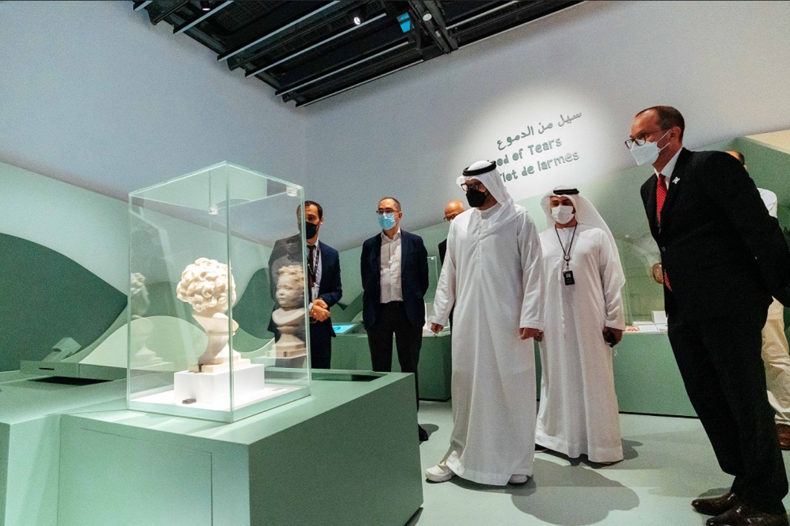
HE Mohamed Khalifa Al Mubarak, Chairman of the Department of Culture and Tourism – Abu Dhabi on tour of the re-opened Children's Museum with Manuel Rabaté, Director of Louvre Abu Dhabi and Amine Kharchach, Interpretation & Mediation Manager at Louvre Abu Dhabi, Department of Culture and Tourism – Abu Dhabi

Abu Dhabi, 16 June 2021: Louvre Abu Dhabi’s Children’s Museum will reopen to the public on 18 June with a fantastic new exhibition that will take children on an interactive adventure of art and activities that will help them identify and explore their emotions.

Combining entertainment and education for children aged four to 10, Emotions!: The New Art Adventure will feature ten artworks and four interactive stations, which will familiarise visitors with four main emotions: joy/serenity, sadness, fear, and anger.

HE Mohamed Khalifa Al Mubarak, Chairman of the Department of Culture and Tourism – Abu Dhabi (DCT Abu Dhabi), said: “We are proud to see the reopening of Louvre Abu Dhabi’s Children’s Museum with this new interactive, entertaining and safe exhibition. Art can be a powerful medium to both inspire a child’s creativity and add to their emotional wellbeing.”

Manuel Rabaté, Director of Louvre Abu Dhabi, said: “We are thrilled to once again welcome children and families to the Children’s Museum, especially to an exhibition that explores emotions. The Children’s Museum is at the heart of our mission to inspire the next generation through art. We hope families in our community will experience this safe and affordable place to learn and play during these summer months.”

The Children’s Museum is free to all children. Families need only purchase museum admission tickets for accompanying adults for the whole family to access all Louvre Abu Dhabi galleries and exhibitions. Access to the Children’s Museum is included in the cost of admission, which is free for anyone under 18.

To ensure the safety of all visitors, Children’s Museum activities feature touchless components and single-use activity materials. Capacity limits and social distancing in all Children’s Museum spaces will be adhered to, and regular sanitising stations made available.

The Children’s Museum is an ongoing exhibition platform and extension of Louvre Abu Dhabi’s educational programming. Since opening in 2017, it has welcomed children and families with three original exhibitions: Travelling Shapes and Colours (2017 –2018), Animals, Between Real and Imaginary (2018 –2019) and A Costume Adventure (2019 –2020).

Taking a gamification approach to education, the museum will include interactive games and activities that engage all the children’s senses, teaches empathy, helps build an understanding of emotions and their expression, while they play and collect achievement points for tasks completed.

Emotions!: The New Art Adventure will also be accompanied by an extensive cultural programme that will be available at the museum.

Films focussing on emotions will be screened in the museum’s auditorium on Saturdays — 19 June, 26 June and 3 July. The films curated by Rinku Awtani include three feature films: The Secret World of Arrietty by Hiromasa Yonebayashi, The Breadwinner by Nora Twomey, and Inside Out by Pete Docter, in addition to five short films; Looks by Susann Hoffmann, 3Feet by Giselle Geney, AMENTI by Kamela Bentouati and Amandine Dazin, Grandpa’s Nursery Rhyme by Yoshiko Misumi and Hair Love by Matthew A. Cherry.

In addition, Cherry’s Hair Love will also be projected on the museum’s wall on all three days for visitors and kayakers to enjoy outdoors.

As part of the Children’s Museum main activities, local artists Shaima Al Amri, Ali Kashwani and Maryam Al Atouly have pre-recorded virtual workshops that children can engage in at their own pace. The workshops will show children how to express feelings through artistic activities, such as drawing, collage and 2D sculpture.

More information about the film screenings is available on the museum’s website, as well as the option to pre-book a place.

-ENDS-

Notes to editors:
Louvre Abu Dhabi is open Tuesday – Sunday from 10 am – 6:30 pm; closed on Mondays. Pre-purchased tickets are required to visit the museum. E-tickets can be reserved via the museum’s website.
Follow Louvre Abu Dhabi on social media: Facebook (Louvre Abu Dhabi), Twitter (@LouvreAbuDhabi) and Instagram (@LouvreAbuDhabi) #LouvreAbuDhabi.
For more information on Louvre Abu Dhabi’s acquisitions policies and principles, visit our website.
Louvre Abu Dhabi has been certified as a “Go-Safe” site. Our partnership with VPS Healthcare means that the health and wellbeing of our visitors will be prioritized throughout their visit, from timed ticketing to temperature checks, to the ample space to social distance throughout the galleries and outdoor spaces of the museum.

Ongoing offers and promotions:
Teachers are eligible for unlimited access to Louvre Abu Dhabi and its programming with the museum’s Teacher Pass. The Teacher Pass is available at AED 120 for teachers, academics and other educators holding valid accreditation, based in the UAE or abroad.
Further information and terms and conditions on all offers and promotions can be found on the museum’s website: www.louvreabudhabi.ae.

ABOUT LOUVRE ABU DHABI
Created by an exceptional agreement between the governments of Abu Dhabi and France, Louvre Abu Dhabi was designed by Jean Nouvel and opened on Saadiyat Island in November 2017. The museum is inspired by traditional Islamic architecture and its monumental dome creates a rain of light effect and a unique social space that brings people together.
Louvre Abu Dhabi celebrates the universal creativity of mankind and invites audiences to see humanity in a new light. Through its innovative curatorial approach, the museum focuses on building understanding across cultures: through stories of human creativity that transcend civilisations, geographies and times.
The museum’s growing collection is unparalleled in the region and spans thousands of years of human history, including prehistoric tools, artefacts, religious texts, iconic paintings and contemporary artworks. The permanent collection is supplemented by rotating loans from 13 French partner institutions, regional and international museums.
Louvre Abu Dhabi is a testing ground for new ideas in a globalised world and champions new generations of cultural leaders. Its international exhibitions, programming and Children’s Museum are inclusive platforms that connect communities and offer enjoyment for all.

ABOUT SAADIYAT CULTURAL DISTRICT
Saadiyat Cultural District on Saadiyat Island, Abu Dhabi, is devoted to culture and the arts. An ambitious cultural undertaking for the 21st century, it will be a nucleus for global culture, attracting local, regional and international guests with unique exhibitions, permanent collections, productions and performances. Its ground-breaking buildings will form a historical statement of the finest 21st century architecture; Zayed National Museum, Louvre Abu Dhabi and Guggenheim Abu Dhabi. These museums will complement and collaborate with local and regional arts and cultural institutions including universities and research centres.

ABOUT THE DEPARTMENT OF CULTURE AND TOURISM – ABU DHABI
The Department of Culture and Tourism – Abu Dhabi (DCT Abu Dhabi) drives the sustainable growth of Abu Dhabi’s culture and tourism sectors, fuels economic progress and helps achieve Abu Dhabi’s wider global ambitions. By working in partnership with the organisations that define the Emirate’s position as a leading international destination, DCT Abu Dhabi strives to unite the ecosystem around a shared vision of the Emirate’s potential, coordinate effort and investment, deliver innovative solutions, and use the best tools, policies and systems to support the culture and tourism industries.
DCT Abu Dhabi’s vision is defined by the Emirate’s people, heritage and landscape. We work to enhance Abu Dhabi’s status as a place of authenticity, innovation, and unparalleled experiences, represented by its living traditions of hospitality, pioneering initiatives and creative thought.

